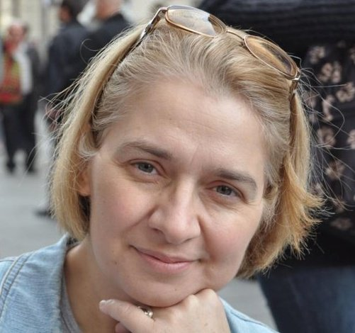
CURRICULUM VITAE

Name: SOFIJANA STAMENKOVIC
DOB & place: 26th Jan 1965, Belgrade, Serbia
Education: High school for mathematics, Belgrade, 1983
(This is a special school for gifted and talented students of mathematics, physics and informatics located in Belgrade, Serbia. It is ranked number one at International Science Olympiads by the number of medals won by its students (more than 400).
Scientific and technical translator for English language, Belgrade, 1991
Belgrade Business School, 2003
ECDL Certificate, Belgrade, 2006
Project managemet Certificate, Belgrade, 2009 (at PricewaterhouseCoopers Training Academy)
Proz Profile: http://www.proz.com/profile/108827
CAT tools: Trados 2007, Trados Studio 2009, Trados Studio 2014

Work experience as a translator (and proofreader):
In 1991 I acquired the title of Scientific and technical translator for English language (Association of Scientific and technical translators of Serbia). Since then, I’m permanently engaged on a various translations for my private clients (translations differ in volume, fields of speciality, etc.) Some of them include:
- User manuals and marketing texts for home appliances, digital cameras, smartphones, notebooks/laptops, etc. for various renowned manufacturers (Samsung, Electrolux, Nikon, Olympus, Fuji, Genius, etc.) ,
- Media/marketing texts for various renowned companies operating in automotive, truck, aerospace, electrical & hydraulics industry (Mazda, Chevrolet, Pirelli, Daimler, Renault, Caterpillar, Eaton, etc.)
- Media releases and manuals for printers and copiers (MFDs) - for a major USA company,
- Weight - strength analysis of aircraft structures, Aircraft structural design - basic,
- Web site translation (various contents: HR, technical, travel, personal, etc),
- User manuals for satellite dishes for renowned European manufacturer,
- Import of cars manufactured in a Far East country: Detailed specification / comparison of various models (including Feasibility study / Business plan),
- Operating manuals and Instructions for use for various medical devices and accessories manufactured by Gambro, Fresenius, Baxter, NIPRO, Belco, SORIN Group Italia S.R.L, MEDELA AG, REDAX, GE Healthcare, Sysmex, etc,
- Book about wine production technology,
- Materials for an NGO: Help / Education for parents & children,
- Training courses for managers & executives,
- Various contracts / documents / agreements,
- Financial analysis and reports / plans,
- Software for ceramic glaze chemistry calculations,
- Etc…

Also, I have worked on several major localization projects:
- Localization of ”Scala” Software and related manuals for accounting, financing etc.
- Localization of standalone software application produced by Cyberlink,
- Localization of Lumesse ETWeb

Translation of books for a local publisher (1998-2006): HTML 4 for Dummies; Illustrated computer dictionary for Dummies; Windows 98 - Secrets; Visual Basic 6 for Dummies; Visual Basic 6 - Bible; Astrology for Dummies; Excel 2002 for Dummies; Information Technology - Principles, Practices and Opportunities; Repairing And Upgrading Your PC.
Work experience as an economist:
August 1983- July 1987 ”Balkanija” Export-Import Comp.
System operator for NIXDORF computer in Data processing Center.
July 1987 - today ”Energoprojekt Holding Corporation”
1987-1990 - Programmer for DOS and UNIX operating systems for personal computers in dBASE, CLIPPER, Informix SQL. I acquired following certificates: In 1987 Certificate for course of Business English with excellent grade; in 1988 Certificate for dBASE course (40 hours - lessons, practice & exam); in 1989
Certificate for UNIX course (64 hours - lessons, practice & exam)
1990-1997 - Senior officer for planning & analyzing of business operations for Energoprojekt Corp.
1997 - today - Coordinator in Department for planning & analyzing Energoprojekt's activities from the Holding level. The function of this Department is to embrace all planning and control elements of the Energoprojekt system, from the business and financial aspects.
Other:
Project managemet basics Certificate, Belgrade, 2009, at PricewaterhouseCoopers Training Academy
I have written a book for children (age 6-16) about ancient civilizations of Egypt, Greece, Rome, India, China and Mayas, published by "Mikro knjiga" in April 2002. (www.drugacijisvet.cjb.net). The book was "NEVEN" award winner for the best children's book in 2002 Popular Science Category.
Advanced PC user: Internet software, ECDL Certificate (covers the entire MS Office) and also familiar with few features of Corel Draw, Adobe Photoshop, InDesign...

Contact:
e-mail1: sofijana.oj@gmail.com
phone No: +381-64-112-0461

