Translator / Localizer/ DTP

Mohammed Elsayed Mostafa
Wali Al-Ahd St. Tower Qasr El-Nadda, Hadayek El Kobba, Cairo - Egypt
Land line: 0020248266590 - Cell Phone: 00201116880968
Curriculum vitae
Personal information
Surname | Mostafa
First name | Mohammed
Date of birth | July 9th,1978
Place of birth | Cairo – Egypt
Nationality | Egyptian
Gender | Male
Marital status | Married
Cell phone | 00201116880968
Landline | 0020248266590
Home address | 45 Wali Al-Ahd St. Tower Qasr El-Nadda, Hadayek El Kobba, Cairo - Egypt
National ID No. | 27807090100834
E-Mail address | elrayanypro@yahoo.com  elrayanypro@hotmail.com  elrayanypro@skype.com

Objectives:

It is really a great pleasure to offer you my services as a freelance translator works from English into Arabic languages and vice versa. I am Mohamed El-Sayed; an Egyptian Translator, I have been working as a full-time freelance translator since 2001. I have performed various language-related tasks for several government offices, and for well-known translation agencies all over the world especially in the United States and United Kingdom. In addition, I have provided language services for the most reputable corporations around the world.

I specialize in IT, Journalism, GIS (Geographical Information System), Conversation, News, Letters, Military, Politics, Automotive, Tourism, Brochures, Correspondences, Literature, but I have also worked on Translations with subjects as Movies' scripts, Computers, Technical Manuals, Transcription, Greetings, Legal document, Occupational Health and Safety.

I am a native speaker of Arabic, born and raised in Egypt. I am deeply involved in the English-speaking world by reading English newspapers, watching English movies and conversing with English speakers. I have acquired a great deal of knowledge related to Translation Techniques.

I work full time as a freelance translator, have state of the art equipment, SDL Trados Studio 2009 Freelance Plus, SDL Trados Version 7.0 Freelance and specialized dictionaries to assist me in my duty. I did not only take this step to empower you with my experience and skills; but also, to enhance myself throughout a wide range of interchange and positive reaction. I am looking forward to working with you in order to meet your language needs.
Qualifications

Foreign languages knowledge

Arabic: Mother Tongue
English: (fluent) written & spoken
Germany: (fluent) written & spoken

Educational History

Period |  | Qualifications obtained | University, Institutes, etc. | Country
1998 - 2001 | B.A  (Bachelor of Arts) |  | Helwan University  Faculty of Arts  English Department  First Language: English  Second Language: Germany | Egypt
1995-1998 | General Secondary Certificate |  | General Secondary Certificate, El-Nokrashy Secondary School. | Egypt
Near future | Seek to obtain Diploma in Translation field.

Software

I have an excellent command of computer–aided translation tools. I am using Trados version 7.0, SDL Trados Studio 2009 Freelance Plus, Microsoft office XP, Microsoft Excel, Microsoft Word, (QA Distiller), PowerPoint, SDL TRADOS and Nitro PDF Professional. I am also an expert in terminology management using Trados MultiTerm 7. I am familiar with Windows Environment software and excellent internet surfer and Professional navigator, also I am using Adobe InDesign, QuarkXpress, Adobe Illustrator, Adobe PhotoShop, Adobe PageMaker, Adobe Acrobat, MS Office, MS Front Page, Html, Css, Xml, Xsl, SGML.
N.B: Other Computer applications could be provided upon request.

Experience

- I am currently working as a Freelance translator for many agencies and Outsourcers around the world especially in the United States and United Kingdom.
- Full time translator and interpreter at a tourist Company with principal place in Saudi Arabia from 6th October 2004 till 10th 2006.
- Freelance translator at Nile TV International & Egyptian Satellite Channels (ESC), from November 1st, 2001 till September 1st 2004.

Services

Translation

Translating and localizing major projects including user manuals, web pages and brochures for reputable clients such as BG group company, Force protection industries, Inc, ImagineNations™ website, Kingdom of Saudi Arabia Presidency of Meteorology and Environment, also GIS training courses for the Yemeni government.
Notice: Kindly find the attached samples.

Editing & Proofreading

After finishing the translation, I reread the translated work to see for example, whether the paper is well-organized, the transitions between paragraphs are smooth, and my evidence really backs up my argument, then focusing on surface errors such as misspellings,
Grammatical errors and punctuation.
Localization

Software and Web Site Localization, Technical Translation, Internationalization, Multilingual Typesetting, Production and Management.
DTP Services

Adobe InDesign CS3, QuarkXpress 5.0 (Pc), Adobe Illustrator CS2, Adobe PhotoShop CS2, Adobe Acrobat 6.0, Adobe PageMaker 7.0, MS Office 2003, MS Front Page, XML Spy.
DTP Rate: 05.00 USD/Page.
Notice: Kindly find the attached samples.

Skills, Background and personal characteristics

I have the ability to work under pressure, Reliable, Goal-oriented, Organized, Hard worker, Accurate and I restrict myself to submit the Translated work before the deadline.
I have a background concerning Technical and Automotive Translation, I have translated a big project contains about 300.000 words for Force Protection, Inc http://www.forceprotection.net which is the world's leading manufacturer of ballistic- and blast-protected vehicles, The project was about the ILAV (The Iraqi Light Armoured Vehicles) which have been used to support armed forces and personnel security in Iraq, Afghanistan, Kosovo and other hot spots around the globe.

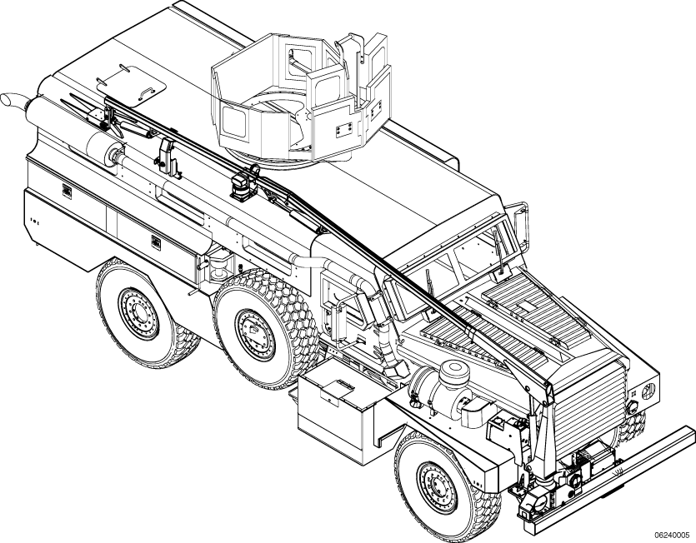
Figure (1-1) The Iraqi Light Armoured Vehicles

Notice: Kindly find the attached samples and letter of reference.

I have translated political news for Alhurra channel which is a United States-based satellite TV channel, sponsored by the U.S. government. It began broadcasting on February 14, 2004 in 22 countries across the Middle East.
Notice: Kindly find the attached samples.

Rates

- Non-Technical Rates: (Journalism – Accounting – Banking – Commercials - Financial – Economics – Journalism – Letters –Correspondences – Literature – Drama – Arts – Cinema(.
- English > Arabic: 0.04 USD /word.
- Arabic > English: 0.04 USD /word.
- Technical Rates: (Automotive - Computers – Information Technology - Sciences – Engineering – Medicine – Mining - Pharmaceuticals – Photography - Photography).
- English > Arabic: 0.05 USD /word.
- Arabic > English: 0.05 USD /word.

For more information, kindly visit my profiles on:
http://www.proz.com/translator/119261
http://www.elrayany.TranslatorsCafe.com

Notes

For any further information, inquiries, samples, tests, quotes…etc,
Feel free to contact me.
Always at your disposal
Best Regards
Give it a try! Contact me

Sincerely,
Mr. Mohammed Elsayed Mostafa
Email: elrayanypro@yahoo.com
Cell phone: 002 0111 68 809 68
Land line: 0020248266590

References are available upon request

