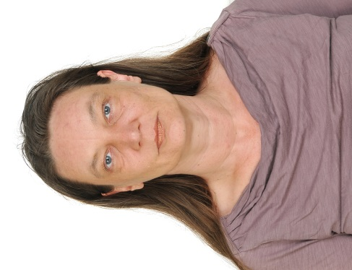

Personal details:

Name: Angela Scheffler

Address: Brandenburgische Str. 4
D-10713 Berlin

Date of Birth: 4 June 1968

Nationality: German

Home phone: +49 30 54 81 41 34

Email: lychen68@yahoo.de

Education:

Jun/1999 – May/2000 Online business translator and
bilingual secretary (German, English)
Didactica
Chamber of Commerce exams (IHK Berlin) on both subjects

Jul/1989 – Jun/1994 Law-studies “first state examination”
(recognition as a law degree in July 2004)
FU Berlin
1987 A-levels
Employment:

Jan/2011 - Free-lance translator (English -> German)
specialisation: economics, law, psychology, psychiatry
- contracts,
- judgments,
- summonses,
- other legal documents,
- web-pages,
- texts for the journal of the German Hearing Voices Network NeSt (psychology)
- book: “The Bipolar Workbook: Tools for Controlling Your Moodswings”, German edition: BALANCE buch + medien Verlag

Feb/2001 - Dec/2010 Bi-/multilingual secretary for temporary work agencies

- Humboldt-Universität zu Berlin
- Emerson Climate Technologies
- MSA Auer
- Bayer Schering Pharma

Jun/2000 – Oct/2000 Bilingual secretary (German, English),
Schering, Berlin

Feb/2000 – May/2000 Trilingual secretary intern (German, English, Italian), B.Braun, Berlin

Oct/1996 – Oct/1997 Legal clerkship
Kammergericht (Supreme Court)
- progressed through the civil and penal stages

May/1995 – Sep/1996 German teacher,
Berlitz and Oxford institutes italiani, Milan (Italy)
- courses for groups and individuals, classes in firms
- creation of pedagogical material (e.g. memory-games)
- creation of a booklet accompanying a BBC-video course to bridge the gaps between the video course and the Berlitz-materials
- assessment of German skills of new students

Aug/1995 – Jun/1996 Lecturer in German legal language, Università Statale, Milan (Italy)
- comparative law
- basics of German civil and commercial law
- German grammar

Jul/1994 – Feb/1995 Freelance in research,
Carola Bubach, law firm

Aug/1994 – Feb/1995 Evening secretary,
Oppenhoff & Rädler, international law firm

Aug/1994 – Feb/1995 Secretary, kardiologische Gemeinschaftspraxis (joint practise of cardiologists), Berlin

Nov/1991 – Mar/1992 Lecturer in office communication, PBL (private vocational school), Berlin
- classes for groups
- German,
- phrasing of letters,
- drawing up of letters with the computer (Word),
- office-related knowledge

Computer skills: Word, Excel, PowerPoint, Wordfast, Scribus

Languages: German – native speaker C2

English – business fluent/translator C1/C2

French – good working knowledge B1

Italian – fluent (working stint in Italy) B2/C1

Legal/political publications: - “Der freie Wille” in: Psychosoziale Umschau, Psychiatrie Verlag, 31. issue, p. 28
- Opinion piece for § 28 PsychKG (“Offener Brief”) in: Unser kleines Stimmenhörerjournal, NeSt, 18. issue, December 2015, p. 35
- Opinion piece for § 6 PsychKG (“Anschreiben an den Berliner Senat”) in: Unser kleines Stimmenhörerjournal, NeSt, 17. issue, June/July 2014, p. 5

Hobbies: swimming, yoga, walking, meditation, art, painting,
DVDs, books and audio-books
(German, English, Italian, French), podcasts on economics and meditation or spirituality

