YURI PAVLOV
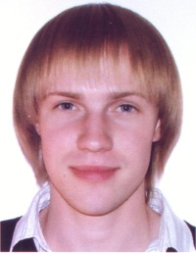
11-280 Lobanka St. | (033) 661 75 06
Minsk 220019 | yuri.yonas.pavlov@gmail.com
BELARUS | Skype: yurypaulau

Career Objective: | Translator/interpreter
Skills: | - Technically proficient in MS Word, Excel, Power Point, Acrobat Reader, Adobe FineReader, Internet  - Touch typing  - Skilled with office copying equipment, scanning, fax  - Fluent English (advanced), intermediate German, basic Spanish  - Translating socio-political articles from English into Russian  - Fast learning  - Summarizing various documents in theses form, public speaking
Experience: | 2010-2011: Office worker in Berea College Public Safety  Berea, KY, 40404 USA  July 2010: Interpreter at the World Rowing U23 Championship  Belarus Rowing Federation  Brest/Warsaw  2008: Front desk at Cabana Motel  Ocean City, MD, 21842 USA
Education: | 2006 – present: Belarusian State University (BSU)  Faculty of International Relations  Linguistics Major  2010-2011: Berea College, KY, USA;  fellowship through Global UGRAD Program  (http://www.irex.ru/programs/ugrad)  U. S. Studies Major
achievements: | April 2010: First prize in the English Student Competition in MSLU among universities of Minsk  2007-2010: Prize-winning places at annual BSU spring conferences
Interests/  Activities: | - Languages  - Journalism, psychology, cultural studies, literature  - Contemporary strategies of educational process  - Short film making (http://www.youtube.com/watch?v=uySCk19a_58, http://www.youtube.com/watch?v=jhU4JME2w_w)

