Patricia Alejandra Faúndez Ríos
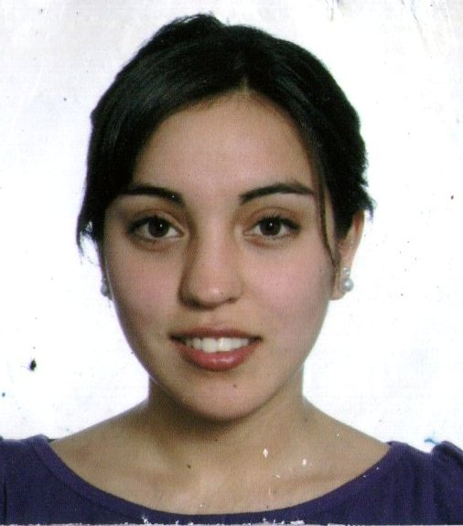
e-mail: kazami.euv@gmail.com
Identity card number: 17.293.200-2
Cooperativa Stadium Boots,
Pasaje 2 Poniente 615 – Peñaflor
Marital status: soltera
Birth date: 21st March, 1990
Mobile phone: 79021419

Academic Background:

Elementary school : Colegio Municipal República Checa

High school : English College

Higher education : Bachelor of Applied Linguistic and Translation with English-Portuguese Mention: Universidad de Santiago de
Chile.

Others

2003 : Modeling course in CECATEP institute.
March – December 2009 : Drama course “Érase Una Vez”, directed by
Mr. Mauricio Inzunza.
June – October 2010 : Course of Sustainable Turism Valle del Maipo.
2011 : Participation in the XVII Encuentro Internacional
SONAPLES (Sociedad Nacional de Profesores de
Lenguas Extranjeras en la Enseñanza Superior)
Antecedentes Laborales:

2008 - 2011 : Saleswoman Oriflame products by catalog.

Julio - 2009 : Liceo Industrial Rafael Donoso Carrasco’s
librarian.

2010 – 2011 : Polyfunctional working in Woodbury Ski Area (ski
center) in Connecticut, EE.UU.

Septiembre – 2011 : Bilingual host reserves English-Portuguese, Valle
Nevado.

Octubre – Noviembre 2011 : Bilingual waitress English-Portuguese at Cafetto’s
restaurant, Orly Hotel.

