DIMITAR STOYCHEV
41 Antim I str. • Sofia, Bulgaria •
Cell: (00359) 887 39 90 35
m_stoychev@abv.bg

••••••••••••••••••••••••••••••

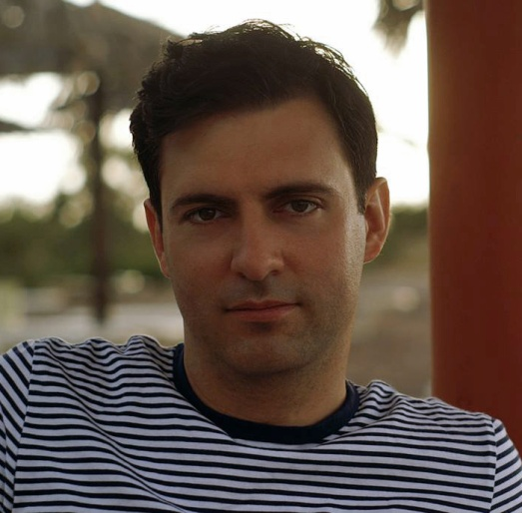
Interpreter/Translator
SUMMARY: Freelance Interpreter/Translator with huge experience in interpretation and translation between English and Bulgarian
Summary of Qualifications

• More than 15 years experience.
• Native Language Bulgarian and Master Degree in English Language.
• Proven excellent written English.
• Exceptional simultaneous interpretation skills.
• Master Degree in Law
• Proven ability to translate legal and official documents, IT and technical translations.
• Excellent communication and presentation skills in both Bulgarian and English.
• Excellent team working abilities.
• Excellent computer skills (MS Office, Word, Access, Excel, Power Point, CAT Tools).
• Highly motivated and results oriented with the ability to plan ahead.

Professional Experience
1. Self-employed
2010 - Present
Interpreter/Translator
- Interpretation and translation between Bulgarian and English
2. Shambala Consult – Legal Company
2005 - 2010

Interpreter/Translator in Legal English
- Interpretation and translation between Bulgarian and English
3. Private High School “Peio Yavorov”
2000 - 2005
- English Teacher

Education
1. English Language High School – English language
1991 - 1996
English Language

2. Master Degree in Law - Sofia University “Kliment Ohridski”
1997 - 2003
Legal English, Civil Law and Proceedings, Penal Law, International Law, Contractual Law,
Real Estate Law, Labour Law, Commercial Law, Company Law, Copyright and Intellectual Property,
etc.
3. Master Degree in English Linguistics - Sofia University “Kliment Ohridski”
2003 - 2008

English language

Social skills and competences
Sociability, diplomacy, tact, facile and rapid integration in different social groups and spaces, good human relation, public speaking and communication skills

Organisational skills and competences
Experience in Project Management and logistic, coordinating and training teams

Computer skills and competences
Excellent command of Microsoft Office tools (Word, Excel, Power Point, Outlook), CAT tools, SPSS, Internet Explorer, Photoshop, Adobe Illustrator, Corel Draw
Artistic skills and competences
Art Photography, Classic and Jazz Guitar
Other skills and competences
Athletics, Skiing (a ski instructor certificate)

