Vishnari Sukkasem | 45/3 Moo 6, Patan,  Mueang Lop Buri, Lop Buri 15000  Thailand  Phone: +66827212349  Email: vishnari@outlook.com  ohsokat@hotmail.com  Skype ID: vishnari@outlook.com
Personal Details:  Age: 23  Date of Birth: 30 May 1992  Nationality: Thai  Language: Thai (native) and English |  |  |  | 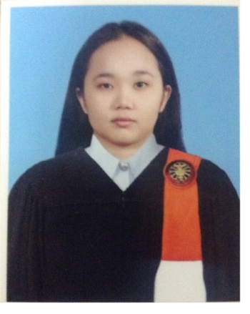
Job Objective:
I am a freelance translator seeking a translation job that will allow me to further my knowledge in business, technology, and other fields. With great determination of a fresh graduate, I aim to prove my worth as a responsible, detail-oriented translator.
Education:
Bachelor of Arts (English)  Thammasat University  Major: English Minor: English Language and Literature |  | 2011-2014
Experiences:
Freelance Translator |  | January, 2015 – present
- Translating tour reviews and how-to articles from English into Thai
- Translating legal documents (i.e. birth certificate) from Thai into English
Editorial Trainee  WeLearn Co.,Ltd. |  | June 2nd – July 26th, 2014
- Translating texts from English into Thai
- Editing translated texts to improve readability
- Proofreading to detect and correct errors in layout and spelling
- Ensuring that the meaning of the source text is retained
- Planning the contents of publications according to the publication’s style
Skills:
Computer literacy in Microsoft Excel, PowerPoint, and Word
Language pairs:
English to Thai (rate: US$0.04-0.08 per English word)
Thai to English (rate: US$15-25 per page)
Translation capacity:
800-2,000 words per day

