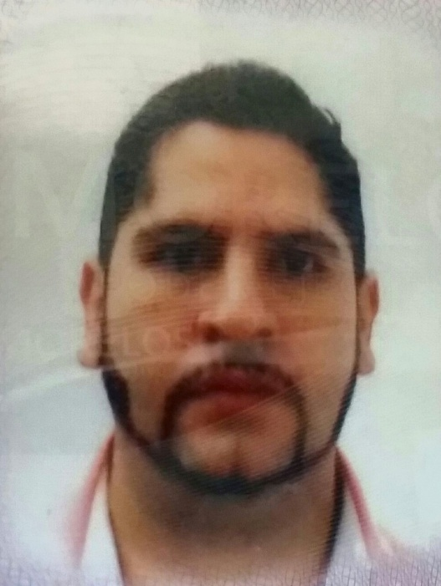

CV

CURRICULUM
Ricardo Salazar Mendoza
Data of birth:7/31/1992
Sex: Masculino
Civil State:Married
Family: 3
Schooling:
Direction and administration of companies degree.
English learning 1, 2, 3 Years (Ingles individual)
Experience: JOBS IN SAN LUIS POTOSI
Promoter in a computing school Centro de Informatica In the city El Maiz(CICM), 1 AÑO (run around houses and enroll students)
JOBS IN CUERNAVACA
-Taxi driver ( years-TAXI RENT)
-Radio operator (2 years )
-English teacher (Ingles individual 1 years)
-Waiter at a restaurant (2 years
Aditional Requirements:
- Linces in forcé until 21/05/2015 (CHOFER)
- Available time (24 HRS.)
Live in:
COLONIA CUAHUTEMOC
CALLE TLALOC MZ#24 LT#55
ZIHUATANEJO, GUERRERO
CEL: 755-120-5855

