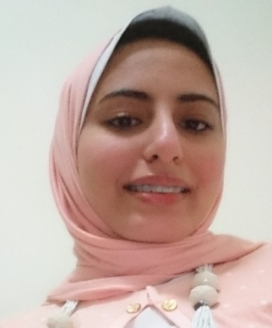

Eman Ahmed Younes

Personal Identity:
Place/Date of Birth : Kafr El Dawdar, Al Buhayrah, Egypt, 3rdJanuary 1993
Address : Younes manor, Kafr El Dawdar,Egypt
Phone : 01111139887
Email : emanyounes64@yahoo.com

Education:
- 2009–2015 Graduated from Faculty of language and translation,
Pharos University.
Grade B GPA 2.55
- 1997 - 2009 El Safwa Private English language school.

Certificates:

- I have achieved level 9 in SEPT test at School of Continuing Education.
- I have attended the Learning & Development Conference ” INNOVATION IN EDUCATION” on 28 of November,2015.
- I have achieved a written translation diploma at Notting Hill College.

Skills
.
- Soft Skills:
  - Time management skills.
  - Communication skills.
  - Very good eye contact with the students.
  - Great ability to deal with slow learners.
- Languages:
  - Arabic, mother tongue.
  - English, very good.

- Hobbies:
- Reading English novels and stories.
- Logging on the internet.
- Listening English movies.

- Goals and objectives:

- To obtain a position as an English teacher.

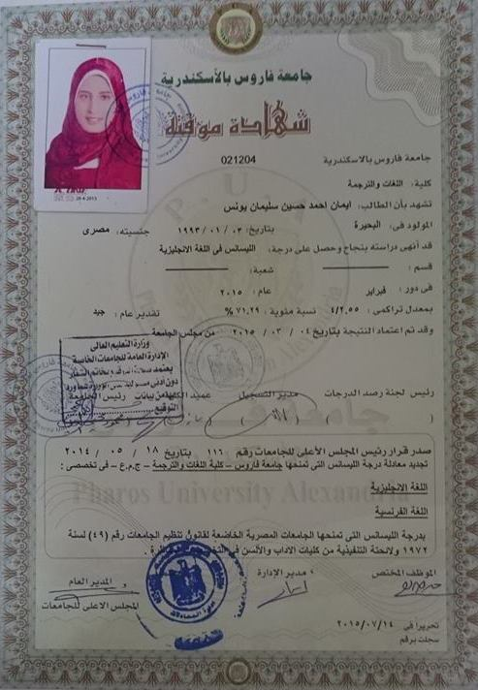

Eman Ahmed Younes <e.a.younes@sce.aucegypt.edu>

AUC: Test Score Result

sce@aucegypt.edu <sce@aucegypt.edu> Tue, Sep 8, 2015 at 1:30 PM
To: e.a.younes@sce.aucegypt.edu

Thank you for applying at the School of Continuing Education (SCE) of the American University in Cairo. Following is your test result:
• Test Name: SHPT
• Test Date: 2015-09-08
• Course Title: Maturing Learners 1
• Course Title: Maturing Learners 1
• Course Code: ENGG411
We appreciate your interest in the School Of Continuing Education and wish that we may be of help in your future studies.
Thank you.

_____________________________________________________

