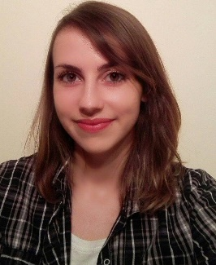
Louise miranda

personal information
Place and Date of Birth: Florianópolis, Brazil | 15 Apr 1992
Phone/ WhatsApp: +49 [ 01577 201 2212 ]
E-mail: [loudemiranda@gmail.com ]
Skype: [ loudemiranda ]
Objectives

Work with communication in a multicultural environment.

Education

02/2010 – 06/2014 Centro Universitário Estácio de Sá Florianópolis, SC
- Social Communication
Emphasis in Journalism

Experience

02/2015 – 03/2016 Upstream Systems Athens, Greece/
Zagreb, Croatia
Copywriter – Marketing
Main activities: Development of marketing campaigns for Brazilian mobile operators (as TIM, Vivo, Oi, Claro and Nextel); Creation and translation (EN-PT/PT-EN) of content for mobile services, such as SMS, applications, websites, promotions; Marketing research about the operators and their services; Campaign results analysis.

11/2011 – 02/2015 SBT Santa Catarina Florianópolis, Brazil
Producer – Journalism
Main activities: Arrange interviews; Produce assignments; Write content to the TV station’s news; Text editing; Check information; Assist TV reports production.

12/2011 – 08/2012 Global Scout Management Florianópolis, Brazil
Press officer
Main activities: Creation of press releases; Follow-up with journalists/media vehicles; Creation of content for a blog; Arrange interviews in the local media to promote the company; Clipping of published articles about the company in the media.

09/2011 – 12/2011 Studio Clipagem Florianópolis, Brazil
Intern
Main activities: TV clipping.

LANGUAGES

• Portuguese - Native
• English – C1
• Spanish – B2
• German – A2 (currently studying in Germany)
Technical skills

Microsoft office package – Advanced
Adobe Premiere - Advanced
Adobe Photoshop - Beginner
Adobe Illustrator - Beginner
Adobe InDesign - Beginner
Interests

Photography, healthy activities (jogging, gym, sports), reading, writing, movies, music, traveling, learning new languages and new cultures, nature, animals.

