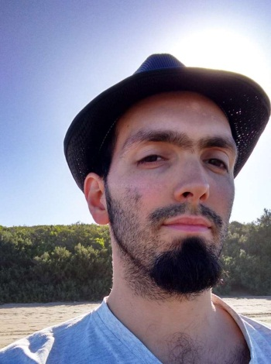
Numa Tesei Obirek
(+54) 11-5965-6020 – Argentina
(+353) 089-488-4115 – Ireland
(+65) 8247-2941 – Singapore
numa.tesei.obirek@gmail.com
Skype: numa.tesei.obirek

Personal information
Address: Beltran 313 (1876)
Bernal, Buenos Aires, Argentina
Date of birth: July 16, 1989
Citizenship: Argentine

Education
(2015) – International Proofreader
of Spanish Texts Fundación Litterae

(2008-2013) – BA in Computer Science
Universidad Tecnológica Nacional

Working Experience
Hello! I’ve been in the IT industry for the last 6 years, more specifically but not limited to software development. During that time I started translating websites, mobile apps and desktop software mainly for the city council of my home town.
In June 2016 I started traveling around the world and became a full time freelance translator in the fields of IT, internet marketing, gaming and language learning.
I have translated, proofread and adapted text, transcribed and also done a bit of subtitling.
Right now I’m part of Games on Words, a group of young translators working in the videogames business and IT.

Hobbies
- Music (piano, guitar)
- Languages
- Traveling
- Fitness
- Video games

