CURRICULUM VITAE

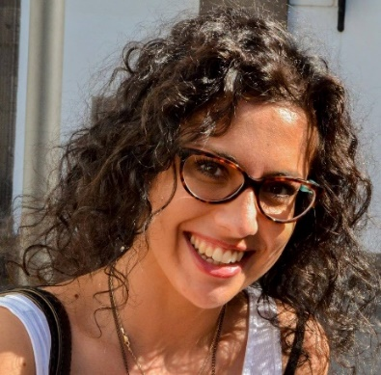
giulia ciampalini
Address: Via Firenze 24, 41037, Mirandola, MODENA
Email address: giulia.ciampalini90@libero.it
Nationality: Italian
Date of birth: 31/05/1990
Phone number: +393394351351
PERSONAL INORMATION

I am an Italian interpreter and translator, graduated from the University of Trieste and with a Master’s degree obtained in the University of Las Palmas de Gran Canaria in professional translation and intercultural mediation. I am looking for a job that can enhance and improve my potentialities and the knowledge of the languages I work with. The company I will be working for can rely on a dynamic and active person, available to move abroad, open to team work and able to handle stressful situations. My degree allows me to be very flexible from a working point of view, as with the right training, I can work in various departments, from commercial to marketing.
WORK EXPERIENCE

Interpreter and sales management assistant
Cima S.p.A., Mirandola
jan 2017 – current
I specifically work for the CEO of the company and my duties are directly related to his position.
- Regarding the translation part, I mainly translate the manuals of the devices the company produces and the daily email flows between the company and the foreign customers. As regards the interpretation part, I am in charge of the interpreting services during conference calls, fairs or meetings with foreign customers at the company’s premises. The languages I work with are Italian, English and Spanish.
- Furthermore, I manage the foreign customers’ orders: I follow the whole order procedure, from the reception to the pick-up organization with the forwarder.

Freelance liaison interpreter (ITA>ENG/SPA, ENG/SPA>ITA)
SEP 2014 – oct 2016
Fair Marmomacc 2016, Verona (Stone Age International, Jaipur, India)
Fair VicenzaOro 2016, Vicenza (Alias Concept, Cordoba, Spain)
Fair Zoomark 2015, Bologna (Pacdog, Dublin, Ireland)
Fair Vinitaly 2015, Verona (Antica Cantina di San Severo, Foggia, Italy)
Fair Marmomacc 2014, Verona (Mexico Porphyry & Stones, San Luis de La Paz, Mexico)

Internship
CUCID (Centro Universitario de Cooperación para el Desarrollo), Las Palmas de Gran Canaria
Feb 2016 – Apr 2016
- Organization and management of some international events that took place in Las Palmas in February
Chuchotage interpreter during the above-mentioned events (ENG>SPA, SPA>ENG)

Interpreter and translator
Copygraph Srl, Mozzecane, Italy
feb 2014 – nov 2014
- Interpreter and translator in digital printing and cross-media marketing company, in charge of the webpage translation and of keeping contacts with foreign customers
EDUCATION AND TRAINING

Master’s Degree in Professional Translation and Intercultural Mediation (Interpretation) 2015 –2016
Universidad de Las Palmas de Gran Canaria, Las Palmas, Spain
Final mark: 8,7/10

Main subjects: simultaneous interpreting; liaison interpreting; consecutive interpreting; public services interpreting.

Degree in Interpretation and Translation 2010 – 2014
Scuola Superiore di Lingue Moderne per Interpreti e Traduttori, Trieste, Italy
Final mark: 103/110

Main subjects: liaison interpreting; financial and economic translation; English, Spanish, French and Arabic language and grammar.

LANGUAGES

Mother tongue: Italian
Other languages: English, level C2 (IPEC Certification) – Spanish, level C2 – French, level A2 – Arabic, level A1
ADDITIONAL INFORMATION AND PERSONAL SKILLS

- I have been giving private lessons of English and Spanish for more than two years to students of any age (primary school, secondary school, college, university).
- I improved the knowledge of English thanks to a course I attended in Edimburgh in March 2007, a job I obtained at International Asset Monitor in Guernsey (Great Britain) as personal assistant of the company’s director during the summer of 2008 and, finally, an experience in the United States, where I worked during the summer of 2012 as a hostess at Bar Italia, a restaurant in New York (Manhattan).
- I am available to move and for transfers abroad.
- I love team work and I am a very organized and solution-oriented person. I have high communication skills, obtained through my work experience as an interpreter.
- I am an indipendente user of Microsoft Word, Excel and PowerPoint.

