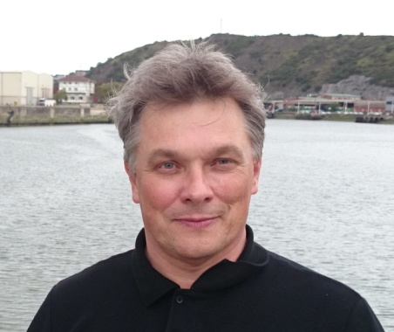
- First name, Family name: Aleksei Makhin

- Language pairs: English-Russian

- Native language: Russian

- Services: Translation, editing, post editing, layout.

- Experience: I've been doing the translations since 1986. In freelance - since 2016.

- Education: Specialist in Electronics Engineering, PhD in semiconductors and dielectrics (material sciences).

- Language education: Translator, English Language (1986)

- Specialization:

- Electronics,
Electrical,
Automobiles and Automotive industry,
Material science,
Physics,
Chemistry,
Engineering and Technology
Technical specifications, Manuals.

- Also working in areas:

Marketing,
Business documentation,
Economics,
Medical equipment,
Sports and sports equipment (skiing, alpine skiing, snowboarding, cycling, swimming, etc.),
Tourism,
Fictional literature (science fiction),
Other.

- Software:
SmartCat, Google Translator Toolkit, MS Word, MS Exel, MS Powerpoint, OpenOffice, Eset Internet Security, browsers, utilities, and more.
Ready to quickly master other programs at the customer's request.

- Additional information about myself: I have a lot of experience in translating texts and documents of various kinds (commercial documentation, scientific and informational articles, technical descriptions, specifications, standards and drawings, promotional materials, Internet sites, etc.) in conjunction with use of these translations in practical activities: in negotiation, engineering developments, transactions, technical documentation development, promotional and informational materials for Internet sites and broadcasts, exhibitions, etc. I have experience of practical work in the fields: microelectronics, physics and chemistry, material sciences, commerce, engineering (special equipment, vacuum technology, automotive industry), management of the organization, project management. Practical experience ensures the accuracy of translations, knowledge of the terminology and peculiarities of the relevant fields.
Communicative, organized, punctual, responsible for the commitments made.
I always respect deadlines and confidentiality.
Living in St. Petersburg, Russia
- Communication:
e-mail: amakhin@yandex.ru
Phone: +7-921-965-3516
Skype: alexey.makhin
I use Viber, WhatsApp, Telegram and Messenger.

- Example of a translation attached (chemistry).

