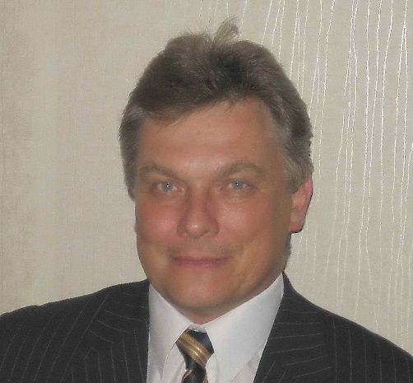
Curriculum Vitae
Alexey V. Makhin

Let me introduce myself.

I am native Russian speaker, professional translator, with a degree in solid-state physics and with background in electronic and electrical engineering, automotive industry, mechanical engineering, material science, chemistry and business administration. That is why I have an excellent understanding of relevant fields of activity and respective terminology. I have been working as English-Russian translator for 30+ years. Having a wide technical background, I specialized mostly in technical translation. Therefore, I guarantee impeccable quality and high accuracy of translations concerning my fields of expertise. I also translate articles on sports, tourism and travel, business issues and other. Besides that, I do editing and proofreading in Russian. I can also arrange text layout or rewrite translated text to make it more acceptable to Russian speaking audience (localization). In addition, I can write original articles in Russian.
I live in St.-Petersburg, Russia.
Quotes
I think that it is no use placing the fixed prices here for there may be different quotes for projects of different complexity, volume, urgency etc. The quotation 2.00 RUR / 0.032 USD / 0.028 EUR per word for the turnkey translation is only for reference. Contact me and we will agree on prices and terms!

MAJOR AREAS OF EXPERTISE:
- Automotive/cars and trucks
- Science (general)
- Physics
- Chemistry,
- Material science,
- Electronics, microelectronics, electrical engineering
- Mechanical engineering
- Special equipment, medical equipment, production equipment, etc.
- User manuals, specifications, technical descriptions, etc.
- Sports (skiing, alpine skiing and snowboarding, cycling, swimming, other)
- Tourism and travel.

CAPACITY AND PERFORMANCE

My daily capacity is about 2500 words (10 pages); therefore, I can translate big volumes at reasonable time. I can work in evenings and on weekends if necessary to ensure the customer’s due dates.

COMMUNICATIONS

E-mail: amakhin@yandex.ru
Skype: Alexey.makhin
Mobile phone: +7-921-965-3516
I use Viber, WhatsApp, and Telegram.

AVAILABILITY

I am available through e-mail, Skype or mobile phone from 10-00 am up to 11-00 pm. I use to answer e-mails and messages within 15-20 minutes.

EDUCATION:

- Dipl. Interpreter and translator, English language / St.-Petersburg State University of electrical Engineering (LETI), Faculty of social science 1981 – 1985.
- Dipl. Engineer/ St.-Petersburg State University of electrical Engineering (LETI), 1980-1986.
- Ph.D. in Semiconductors in dielectrics / St.-Petersburg State University of electrical Engineering (LETI) postgraduate studies, 1987-1991/

SOFTWARE

- Translation software: SDL Trados, TStream, SmartCat, Google Translation toolkit.
- Office software and text processing: MS Office Pro, MS Word, MS Excel, MS PowerPoint, OpenOffice.
- Other: ACDsee, Antivirus programs, Communication programs, etc.
I am able to learn any new software and handle any online translation platform.

SOME HIGHLITED PROJECTS:

- MacDon agricultural machinery manuals, multiple books (>60 000 words). Translation. Customer – a translation agency. 2018.
- Charge—sensitive preamplifier (2300 words)/ Translation, editing, layout. Private customer. 2018.
- HSE documents of Sakhalin Energy (oil & gas. (>10 000 words). Editing. Customer - a translation agency. 2018.

- Recreating the Apple Music App in Framer (IT, marketing). Editing and proofreading (6000 words). Customer - private, 2018.
- Meyn food industry machinery User Manuals (~7 000 words). Translation. Customer - a translation agency. 2018.
- MacDon agricultural machinery. Technical Manuals (~12 000 words). Translation. Customer - a translation agency. 2018.
- Toyota training documentation/Hybrid health check. Translation. Customer - a translation agency. 2018.
- Volume 2 - Subvendor Data_489-593, Volume 1 - Installation, Operation, and Maintenance Honeywell (>7 000 words). Editing. Customer - a translation agency. 2017.
- Airboard Series II Owners Operating and maintenance Manual Airboard Pty. Ltd. (7600 words). Translation, editing, layout. Private customer. 2017
- Aspherical mirror glass. Technical specifications. Convex Gmbh. (14 200 words). Translation, editing, layout. Customer – A Russian manufacturing company. 2009.
- Automotive mirror specifications. Ford Motor Co. (> 15 000 words) Translation. Customer - A Russian manufacturing company. 2002.
- Automotive mirror specifications and testing procedures Magna Donnelly Gmbh. (> 10 000 words) Translation. Customer - A Russian manufacturing company. 2004.

