Translator work experience
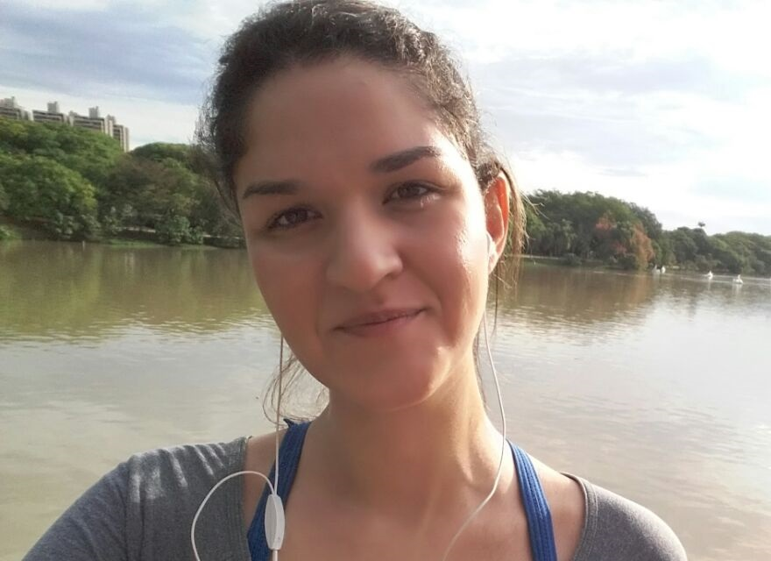

Nadia Silva CASTro
  - TRANSLATOR

PERSONAL SUMMARY
A reliable and skilled translator with a proven ability to translate written documents from German/English/Spanish/French to Portuguese. Would appreciate to work as a freelance translator for successful and ambitious companies that offer great opportunities for progression.

AREAS OF EXPERTISE
Translation
Legal
Software (UIs)
System
Marketing
Other Tasks
Proofreading
Review
DTP

Contact
Nádia Silva Castro
Rua Tiquatira 55, Apto. 62
São Paulo - SP
04137-110 Brasil

T: +55 11 5585 3551
M: +55 19 9 8119 3199
E: silvacastronadia@gmail.com

Bemtraduz - Tritranslation
February 2014 – Present

Papier Translations

JULY 2017 – PRESENT

Zaum Translations

July 2017 – Present

Globaltech

August 2017 – Present

Quicktranslation

March 2012 – July 2012
Work as a translator involved translating, reviewing and proofreading documents and articles. I was responsible for researching appropriate terms to ensure the correct and consistent translation is used, liaising with clients to discuss any unclear points, and using client specific style guides and term bases.

Other Work Experience

kreativ Instituto de lingua

MARCH 2013 – fEBRUARY 2017
Worked as a language instructor. I was responsible for designing and teaching German courses. I was an instructor in a classroom as well as working 1-on-1 with individual students.

Education

São Paulo University (USP), SÃO PAULO, Brasil

MASTER of arts-germanistics (2010-2017)

KEY SKILLS AND COMPETENCIES
- Familiar with translation software tools
- Able to fluently speak English, French, German, Portuguese and Spanish.
- Has both Brazilian and German citizenship and has lived in both countries for over a decade
- Excellent communication and social skills.
- Vast knowledge of both Brazilian and German cultures
- Able to work to tight deadlines.
- Highly skilled in Microsoft Word, Excel and Outlook.
- Competent with Windows operating system
- Able to prioritize work.

references
Available upon request.

