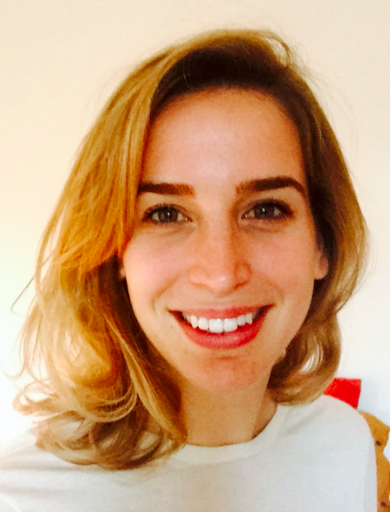
September 2017
WORK EXPERIENCE

Nolwenn DU FOU DE KERDANIEL
TRANSLATOR / CONFERENCE INTERPRETER
ES, EN <>FR

38, rue de la Folie Regnault
75011 PARIS
Contact number: (+ 33)7.81.03.54.72
E-mail nolwenn.dufou@gmail.com
LinkedIn: https://www.linkedin.com/in/nolwenn-du-fou-de-kerdaniel-064b6429/

➔ Translator/ Conference Interpreter freelance (Professional domicile:Geneva)
Translation
- Translating matters: texts EN > FR
- La Via Campesina: texts ES > FR
- Around the Word translation: texts ES > FR
Conference interpreting
- 25/10 – 28/10 ES, EN<>FR Maison des Potes
- 2/11 EN<>FR FSM Antinuclear
- 30/11 – 1/12 EN<>FR ATD Fourth World
- 13/12 – 15/12 ES, EN<>FR La Via Campesina
- 13/01 – 17/01 EN<>FR ATD Fourth World
- 15/02 – 21/02 ES, EN > FR La Via Campesina

September 2015- August 2016.
➔ Teacher of French as a Foreign Language (UPE2A) / Collège André Malraux

- Teaching French to foreign students from 11 to 16 years old.
- Project: meeting and interviews with professionals
- Member of the DELF jury (Diploma in French Language Studies).
- Contact person for the CASNAV (Centre for the education of new arrivals and Travellers’ children).

September 2011- August 2015
➔French teacher / Collège Elsa Triolet

- Teaching French language and literature to students from 10 to 17 years old.
- Creation of a partnership between the school and La Comédie Française: workshops, trips
- Organisation of consultation meetings with colleagues.
- In charge of remedial teaching in French as a Second Language.
- Moderator for focus groups on grammar and spelling learning in collaboration with the teaching staff from other middle schools and our school inspector.
- Correction of the National Diploma of the Brevet and of the DELF.

April 2011 – August 2011
➔ Trainee in charge of internal communication / Bouygues Immobilier
(Issy-les-Moulineaux - France)
• Drafting of articles promoting the company and emphasising individual successes.
LANGUAGES
• Interviews conducted in English, Spanish and French.
• Creation of glossaries, style guides and translation memory files.
• Analysis of campaign performance and language specific data to improve the intranet’s popularity.

A: FRENCH

B: ENGLISH

C: SPANISH

30th July-11th August / Cambridge Conference Interpretation Course
EDUCATION

- Intensive course in the practice of simultaneous interpretation for professional conference interpreters.

September 2017 / National University of Ireland (Galway, Ireland)
➔MA Conference Interpreting

November 2015 / CIEP (Institution dedicated to education and French language worldwide)
- Accreditation to be an examiner for the DELF (Diploma in French as a foreign language)

March 2013
- Certification in FSL (French as a Second Language)

2011 / University Paris – Dauphine (Paris, France)
➔ MA Humanities and Management
- Trilingual Master in English, Spanish and French.
- Macro and microeconomics, corporate finance, international management, communication and marketing classes.
- MAJORS: COMMUNICATION / MARKETING

2010 / University Paris III – Sorbonne Nouvelle (Paris, France)
➔Secondary school teaching certificate-French language and literature

2008 / University of Caen – Basse-Normandie
➔MA French language and literature

SOFTWARES

CAT: Wordfast professional – SDL Trados Studio

Pack Office : Word – Powerpoint – Excel – Outlook- OpenOffice

Others: Photoshop – Moovly – IMovie / Movie Maker – Audacity- Interwrite

HOBBIES

Sport : Boxing

Other : Reiki

