BOCHKAREV SEMYON VLADIMIROVICH
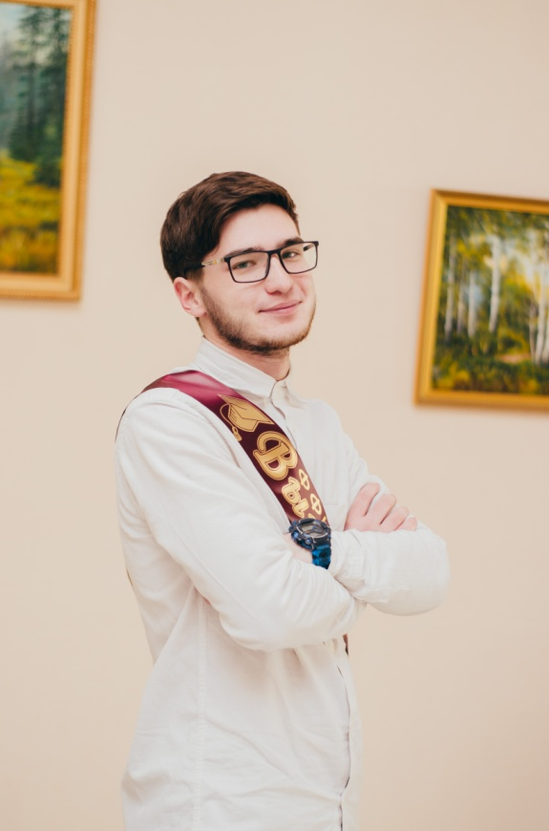 | Personal information:  Date of birth: 5 JULY 1995  Marital status: single  Address: 8 March Street, 38, 51, Birsk, 452451, Russia Phone number: +7-965-645-27-38  E-mail: imleerooy@gmail.com
OBJECTIVE: I’m looking for a position where I can use my foreign language skills.
EDUCATION
September 2013 – July 2018: Birsk branch of Bashkir State University, Faculty of Philology and Intercultural Communication, Bachelor's Degree in the field of preparation: Pedagogical education (with two profiles (English, French).
October – November 2015: Refresher courses: «English language: gas and oil industry».
September 2015 – October 2016: Birsk branch of Bashkir State University, Faculty of Philology and Intercultural Communication, Bachelor's Degree in the field of preparation: Linguistics in the sphere of tourism.
WORK EXPERIENCE
September 2014 – June 2017: Teacher in middle classes.
September 2017 – June 2018: Language tutor, Birsk, Russia.
2016 – 2018: Freelance Interpreter (Smartcat.ai, Proz.com, Upwork.com).
PROFESSIONAL SKILLS
Foreign language skills: English (Master). Deep knowledge of specifics of translation.

PERSONAL QUALITIES
Flexibility, sociability, responsibility, dedication, diligence, high efficiency, result-oriented, organization, stress tolerance.

