Fabiola Granados________________________________
I am a bilingual professional with broad transcribing and translating experience regarding English language; since I am a native Spanish speaker, I translate from Spanish into English and vice versa. I have worked for different end clients for the past three years and, therefore, here are some of my strengths: I am a super-fast typer and deliver results really quick: I also know how to provide the best readability and fluency to end results. Proficiency in DSL Trados,
Here are a few reasons why I think I would be a good fit this job;
- Three years of experience in the education and translation field.
- . My background renders me tools to comprehend and translate captions, audio files, websites, dialogues and several documents contents.
- I am certified as bilingual by a prestigious Institution in my country.
- I am proficient with Microsoft Office Programs, AutoCAD 2015, CorelDRAW 2017, Photoshop CC 2017 and TRADOS 2015.Regarding translation platforms, these are some I have experience with: Wordbee, SmartCat, XTM and Memsource.
- I always include edition and proofreading to guarantee accuracy.

I would love to deepen our discussion about a freelancer job opportunity as I feel that my skills and background would be an excellent match to your needs. I have also attached my CV. I would be immediately available to join your work team.

Kindest Regards,
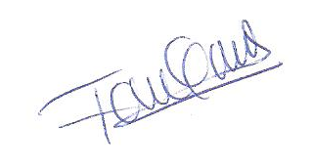

__________________________
Fabiola Granados

