Curriculum Vitae
Personal Information: 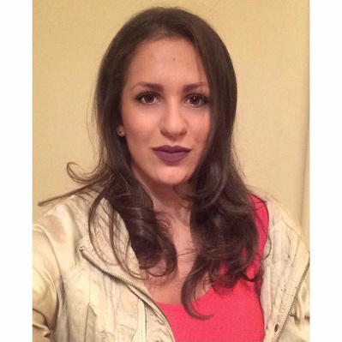
Name and surname: Hristina Stanković
Date of birth: 04/04/1995
Nationality: Croatian
Gender: Female
Adress:Ul. ZoranaGudžića 2G/1, 18000 Niš, Serbia
E-mail:hristinacarica@gmail.com
Mobile phone: +381644761327
Telephone: +38118591959

Education and Qualifications:
- September 2010–September 2014 Economics high school in Niš
Learning areas: Monetary economics, Statistics, Law, Informatics, Macroeconomic Theory, Microeconomic Theory and Marketing.
- October 2014 – June 2016 Vienna University of Economics and Business
Learning areas: Economics, Law, Marketing, Finance, Socioeconomics, Social Skills, Foreign Language Business Communication and Numerical Methods in Finance.

Work Experience:
- 2011-2012 Volunteered and had praxis in the Building Company “Šampion”. Worked as an Administrative Assistant, the most time on the Computer.
- 2012–2015 Gave English and German private classes to the kids and adults in Serbia and Austria.
- 2014 – 2016 Worked as a manager in “Red River Hills” Company for producing organic essential oils. Searched and found customers for wholesale.
- 2016 – 2018 Managed shop team in MSC Cruise Company. Specialized for perfumery team and got special trainings for many different Perfume and Cosmetics Brand.

Additional Skillsand Achievements:
- Three weeks of English Summer Camp at the “International Stanborough School” in Watford (England).
- Finished two years at the Music School in Niš, piano and tonic sol-fa.
- Foreign Language Knowledge:
English: (Reading – Fluent, Speaking – Fluent, Writing - Fluent), B1 (IESOL) from City and Guilds,
German: (Reading – Fluent, Speaking – Fluent, Writing – Fluent), B2,
Italian: (Reading – Fluent, Speaking – Basic, Writing – Basic), A2
Spanish: (Reading – Fluent, Speaking: Basic, Writing - Fluent), A2
Serbian, Croatian: Native
- Attended many Workshops at AIESEC Organisation
- IT skills – Confident in Microsoft Office packages: Microsoft Word – Excellent, Microsoft Excel – Basic, Microsoft PowerPoint – Excellent, Microsoft Publisher and Access – Basic.

Interest and Hobbies:
Literature, Books: Drama and Comedies,
Hobbies: Fitness, Gym, Aerobic,
Enjoy reading, surfing the Internet and working out.

Personal Qualities:
Very communicative person, easy to fit in with all kinds of people. Open-minded person, fine with all ethical differences between cultures, religions, nationalities, races, genders, sexual orientations, etc. I believe I can use in the best way my different language knowledge and skills, during my working duties. Ready to be focused on the each particular text subject and to use previous experience in the following translation responsibilities.
I would be honored to be part of Your team as a home-based worker. I will do my best to impress You and to make sure that all Your expectations are fulfilled from my site.

