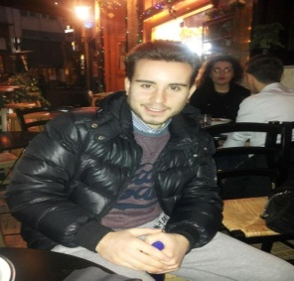
Raffaele FIORINI
Translator/Interpreter/Revisor/Language teacher
09/09/1993
Address: Via Valle Verde 18/18, Rapallo (GE), Italy
Mobile: +393465133047
Email: rafawp93@gmail.com

Work experience as languages private teacher and interpreter (ES>IT, IT>ES). In September I will be taking my master degree. Shown considerable ability to perform autonomously assigned task and excellent familiarity with foreign languages, huge passion of mine. I have organizational and communicational skills, which are fundamental to carry out in the best way any professional duty.

WORK EXPERIENCE
- From 20/10/2015 – Present
Languages private teacher
✓Lessons preparation
✓Exam support
✓Customers relationship management and problem solving

Achievements
✓Adapting my lessons to customer specific needs
✓Empathy
✓Perform autonomously assigned task

- From 03/2017 – Present: UNIVERSITÀ DEGLI STUDI DI GENOVA
Interpreter
✓Traineeship consecutive interpreting ES>IT, IT>ES
✓Customers relationship management

EDUCATION AND TRAINING
- Present: Master Degree in Translation and Interpreting at Università degli Studi di Genova
I am specialized in technical, legal, economical and scientific translations
✓IT>EN and EN>IT
✓IT>ES and ES>IT

- Present: Erasmus Programme +, at University of Warwick, Coventry (UK)

- 2016: Bachelor Degree in Modern Languages and Cultures for Enterprise and Tourism at Università degli Studi di Genova

SKILLS AND COMPETENCES
Language skills
- ITALIAN – Mother tongue
- ENGLISH - Excellent written as well as oral knowledge of the language
- SPANISH - Excellent written as well as oral knowledge of the language
Digital skills
- Office suite
- Internet, e-mail and social networks
- OmegaT and SDL Trados basic knowledge
FURTHER INFORMATION
- Preferred job
✓Translator/Interpreter/Revisor/Language Teacher
✓Available to move abroad

In compliance with the Italian legislative Decree no. 196 dated 30/06/2003, I hereby authorize you to use and process my personal details contained in this document

