Curriculum vitae
Stephen O’Sullivan Traductions S.A.S.U.  29, rue de Bellefond  75009 Paris  France  06 64 85 91 60  stephen@sostraductions.com  Website: www.sostraductions.com | 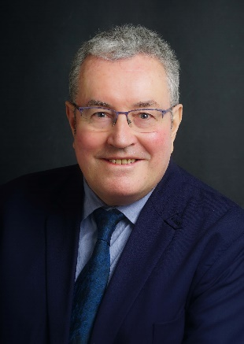

Translator – Reviser: English (mother tongue), French, Spanish
Born on 3rd April 1956 – Nationality: Irish and French
Education:
National University of Ireland:
1976: Bachelor of Arts (Modern Languages)
1977: Higher Diploma in Education
Professional experience:
1989-2017: UPSA Laboratoires (A Bristol–Myers Squibb Company)
Translation and revision of texts for a pharmaceutical industry leader (regulatory affairs, medical, clinical, pharmacology).

1980-1989: OIPC-International Criminal Police Organisation–Interpol
Translation and revision of texts for the organisation’s mission (wanted notices, narcotics, counterfeit currency, stolen works of art, organised crime, etc.)

1978-1980: Teacher of English – Labolangues Cetradel – Paris, France.

1977-1978: English Language Assistant – French Ministry of Education (Lycée Paul–Louis Courier, 37000 Tours, France)

