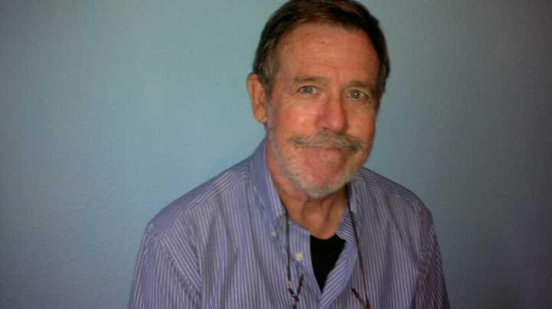PERSONAL
ADDRESS: 39 S. Lanacaster Rd, Savannah, GA.31410
PHONE:
EMAIL: jcumse@hotmail.com
DATE OF BIRTH: 7-18-1952
BIRTHPLACE: ALBERTVILLE, ALABAMA

MARRIED : since 1987 to Teresa Almagro

WORK EXPERIENCE
1979-1982: Campus Minister InterVarsity Christian Fellowship, Atlanta & Augusta GA.
1984-1999: Missionary to Seville, Spain, Youth With A Mission. Hosted short-term mission teams to Spain, lead street evangelism teams in Seville & other Spanish cities, lead short-term mission teams of Spanish youth to USA, Costa Rica. lead YWAM Discipleship Training School. Helped plant NUEVA GENERACION Church.

2000-2012: Associate pastor, NUEVA GENERACION Church, Seville, Spain. Lead MALDICION A BENDICION (Curse to Blessing) seminars.
2012-2017: Lead pastor, NUEVA GENERACION Church.

1993-1997: Head of Studies, Escuela San Pablo Apòstol, Seville Spain.

1993-2010: ESL Teacher, all levels through high school, freelance

2008-2011: Teacher of Comercial English, System Sevilla Este, Seville, Spain

2012-2013: ESL Teacher Academia IFORMA, La Algaba, Seville, Spain. Business English for unemployed; Preparation dor Cambridge B-1 exam.

2012-2015: ESL Teacher, Top English, Seville Spain. Business Englsih; Preparation for Cambridge First Certificate and Cambridge Advanced exams.

2012-2015; ESL Teacher AulaIdiomas, Seville, Spain. Preparation for Cambridge B-1 exams, upper primary (grades 5-6) middle schoool, and high school levels Calle Juan De Zoyas 8, Seville Spain 41003. Telephone. 954 42 12 76

Education

1970-1974: B.Sc. Sociology, West Georgia College, Carrollton GA.
1979-80: Campus Ministry Intern, InterVarsity Christian Fellowship, Atlanta GA.

1983-84: Certificate School of Urban and Cross Cultural Studies, Youth With A Mission, Amsterdam, Netherlands

OVER 30 YEARS´ EXPERIENCE IN ENGLISH-SPANISH, SPANISH-ENGLISH INTERPRETATION FOR CONFERANCE SPEAKERS. CO-TRANSLATER OF THE BOOK IN SEARCH OF TRUTH (SPANISH TITLE, LA BUSQUEDA DE LA VERDAD ) PUBLISHED BY SOVEREIGN WORLD PUBLISHERS.

Skills

