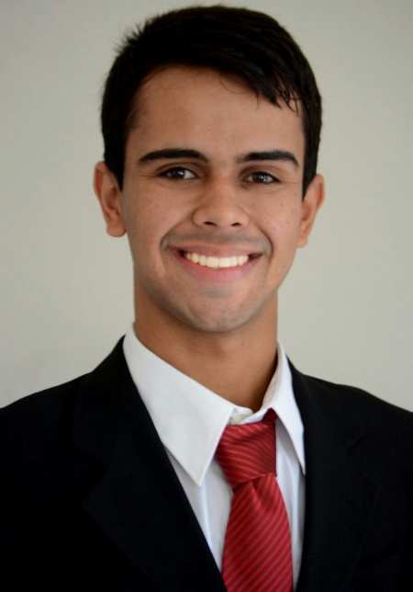
Nationality: Brazilian
Age : 22 years old, .
Address : Estrada São Mateus, n°19 house 3
Duque de Caxias RJ- CEP 25215-283
Cell Phone: (21) 96924-0896 ou (21) 99035-1255

Documentation:
CPF 158.711.627-89
Email: Lucastecla201538@gmail.com

Professional goal
Flight Attendant and Translator.

Training: 2014 / 2015 Logistics Technician - Completed. Estácio de Sá University.
Complementary Course
Basic Emergency ...................................Patrol Civil Rescue Rescue and Rescue Workload 8h.
Formed 2017.
Flight Attendant .......................................Fly training center April 2017 to August 2017
Languages:..............................................English 2008 to 2010 Course Evolution. Intermediate.
Completed.
English Course………………………………Institute: Yes languages (1 year completed)

Professional experience:
Lojas Americanas- Customer Service and Bilingual Recepctionist -10/2015 until 01/2016

Expresso Mangaratiba LTDA - Traffic Operator 07/2016 until 12/2016
Responsible for SOS Reports and Archiving of Employee Guides.
Trel Transturismo Rei LTDA- Pointer C - Traffic Inspection -09/2017 until 11/2017.
Hotel Restaurant Ipanema Plaza –Waiter- Customer Service, Casual Events 2014 until 2016. (Freelancer.)

