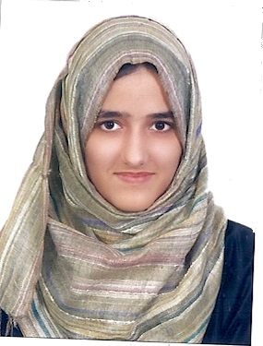

Name: Sania Shah
Contact: 056-9052136
E-mail: sania.shah11@hotmail.com
Date of birth: December 26-1996
Nationality: Pakistani

Personal Profile: A hard working graduate who seeks to get experience and knowledge from the hiring organization.

Education:
- Bachelors in Information Technology from Shaheed Zulfiqar Ali Bhutto Institute of Science and Technology (SZABIST university- Dubai)
GPA- 3.83
- FSC from Pakistan Islamia Higher Secondary School Sharjah
- Percentage scored: 74%
- SSC from Pakistan Islamia Higher Secondary School Ajman
- Percentage Scored: 75%

Work Experience:
- Worked as an intern at Sanipex Trading
- Worked as an intern at Durar advertising
  - Telesales work
- Worked as a subtitler, and translator at amara.org

Technical Experience:
- Languages: C,C++,HTML, Java, asp.net
- Microsoft Office
- Dreamweaver

Skills:
- Teamwork (experience with working in teams during college and university)
- Good at communicating and presenting (experience gained from presenting in class, and job)
- Ability to work well under pressure
- Good at learning

Languages:
- Urdu, English

Projects:
- Developed a 2D game on Stencyl
- Developed a 3D game on Unity
Achievements:
- Honors list of SZABIST Dubai- Fall 2013
- Honors list of SZABIST Dubai- Spring 2014
- Honors list of SZABIST Dubai- Fall 2014
- Sliver Medal for scoring highest CGPA

