Curriculum Vitae

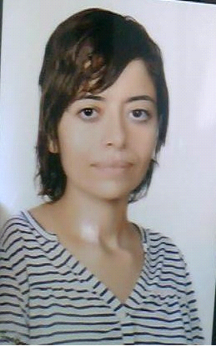 Samiha LAROUSSI
Date of Birth : 07/10/1986
Adress : Eljem 5160 Mahdia-Tunisia
E-mail:arussisamiha@hotmail.fr
Phone Number: (+216)25016527

Education:
2005: | Baccalaureate of Arts.
2005_2007: | Certificate of 1st cycle in English language and literature.
2007_2009: | Diplomat in English language and Literature.
2013_2014 : | Master 1 in applied translation.
2014_2015 : | Master 2 in applied translation.

Experience : | 2011 : Training course at CREFOC in Sfax (regional center of education and continuous training).It was a six-month course that has provided me with the key skills to be a successful teacher. Both the theoretical and practical knowledge I has acquired during the course enable me to successfully deal with young learners.
 | 2011-2017 : teacher at primary school (teaching English And Arabic for young learners).

Skills : | Arabic: Excellent
 | English: Excellent
 | French : Excellent
 | Business Software : Word, Excel

Interests : | Reading
 | Traveling
 | Team sports

