CURRICULUM VITAE
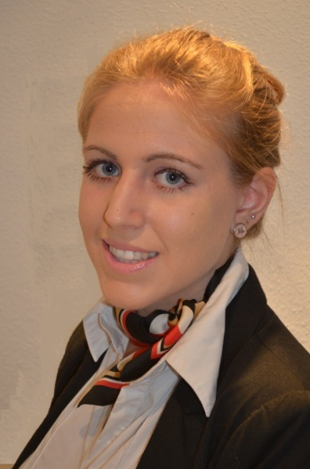
PERSONAL INFORMATION
Surnames: Albusac Muñoz
First name: Belén
Current home address: C/ San Joaquín Nº16A, 4ºD; 18013 Granada (ANDALUCÍA, SPAIN)
Telephone: +34 619-794-444
E-mail: belenam18@gmail.com
Nationality: Spanish
Female
Passport expiry date: 02/06/2020
Date of birth: 08/11/1994
Age: 23
Height: 1,69m
Languages: Spanish, English, French, Russian, Italian, German

EDUCATION AND TRAINING
*October 2017/ in progress: Master Degree in English Teaching for Secondary Education, Upper Secondary Education, Vocational Training and Languages School. University of Granada.

*September 2012/ June2016 – University Degree in Translation and Interpreting. Faculty of Translation and Interpreting. University of Granada

*November 2013/ March 2014 – Cabin Crew Initial Training course. Academy “FORMAS formación”, Granada.

*September 2010/ June 2012 – Higher Secondary-Education Course related to Languages. High School “IES Castillo de la Yedra”. Cazorla (Jaén)

*September 2006/ June 2010 – Compulsory Secondary Education. High School “IES Castillo de la Yedra”. Cazorla (Jaén)

JOB EXPERIENCE
- September 2016/ September 2017: Cabin Crew. Ryanair airlines. Sofia (Bulgaria) and Frankfurt (Germany).
- January 2016/ May 2016: Tourist Information Officer. Tourist Office. Granada’s City Council (Spain)
- June 2015/ August 2015: Au- pair. Lake Elsinore (CA, United States)
- June 2012: Out-of-school activities voluntary monitor. Preschool and Primary Education School. Cazorla (Jaén)
- June 2011: Out-of-school activities voluntary monitor. Preschool and Primary Education School. Cazorla (Jaén)
- June 2011: High School Friendly marathons voluntary organizer. Cazorla (Jaén)

PERSONAL SKILLS AND COMPETENCES
-June 2016: Certificate in Pre-Intermediate French level (B1)
- November 2016: Cambridge Certificate in Advanced English (C1)
- April 2013: Non-verbal Language and Strategic Communication course

LANGUAGES
- Spanish: Mother tongue

- English: Advanced level

- French: Intermediate level

- Russian: Elementary level

- Italian: Elementary level

- German: Elementary level

SOCIAL SKILLS AND COMPETENCES
- July 2012: Stay in Ireland (Bray) for a month in order to learn the language.
- August 2011: Stay in France (Montpellier) for three weeks in order to learn the language.

DRIVING LICENCE
Class B.

