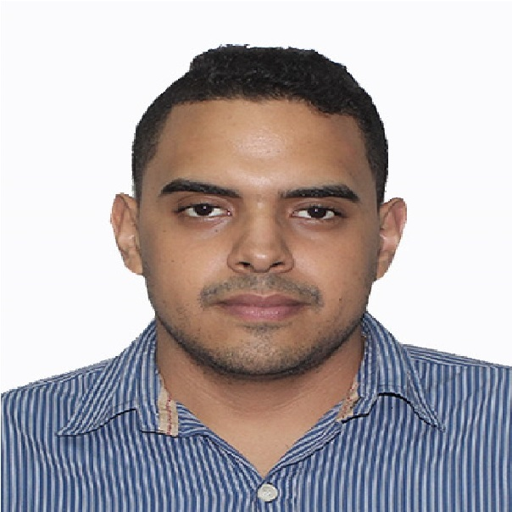
Professional Experience

2014-2017 DMC System, C.A.
Position: Computer Equipment Maintenance and Repair Technician
Function: Providing technical support services (In English and Spanish), repairing, and maintaining computers, laptops and notebooks.

2018 Neevo.definedcrowd.com
Position: Text-Audio Corrector (Directed Speech) (English language)
Function: Type of work varied from text, audio, image and video analysis. Recorded phrases, categorize audio, identify the feeling of a specific text, tag objects in images, among other tasks.

Daniel Martinez Carnevali
Country: Venezuela
I.D: 24213443
Age: 24 years old
Phone N°: +580424242073924
Email: Canevalix2021@gmail.com
Date of birth: September 30, 1993
Academic background:

2015- 2018 Studying System Engineering
College: UNEXPO Vice-rectorado "Luis Caballero".
Intermediate/advanced knowledge acquired in mathematics, physics, chemistry, English, logic and electronics.

2014-2016: Network Engineering Certificate
Academy: KEYS C.A
Advanced knowledge of computer support, printing, wired, wireless networking, and server management.

2017-2018 CEFRL Independent User B2 Certificate
Academy: Centro Venezolano Americano “English as a Foreign Language Program”.

Can understand the main ideas of complex text on both concrete and abstract topics, including technical discussions in their field of specialization.
Can interact with a degree of fluency and spontaneity that makes regular interaction with native speakers quite possible without strain for either party.
Can produce clear, detailed text on a wide range of subjects and explain a viewpoint on a topical issue giving the advantages and disadvantages of various options.

