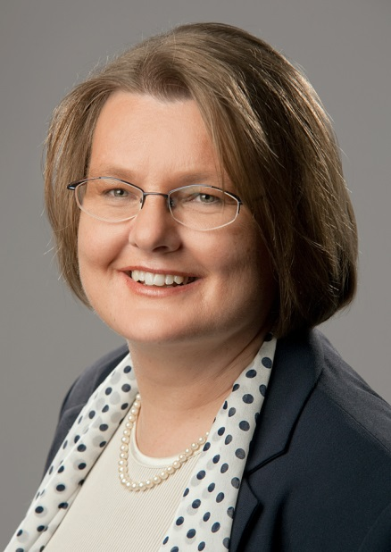
Curriculum vitae

Date of birth: June 29th, 1966

Place of birth: Bochum, Germany

Nationality: German

Marital status: Married

Office: 4a. Calle Lote 108 Fr. 4

Res. Los Alpes
San Lucas, Sacatepéquez

Guatemala (since 2001)

Phone: (+502) 40639431

Email: info@globiztics.com

Skype: utalausberg

Experience as a full-time translator: 14 years

Languages: German (mother tongue), Spanish (near-native level, living in Latin America since 2001), English (active/passive, main working language)

Working languages

Translation: English-German, Spanish-German, German-Spanish (Guatemala)

Areas of Expertise

Business/Finance/Economy, Law, Technology/IT, Medicine and Health Care.

Average turnaround

3000 words per day (translation), 6000 words per day (editing)

Translation experience

Finance: Financial reports, financial statements, audit reports, technical documents on risk assessment and risk management, annual reports, incentive systems, financial press releases (stock market), technical documents on fraud and fraud detection etc.

HR: Executive training packages for leaders & vendors, online training courses, Health and Safety training packages, HR Websites, HR intranet sites, psychometric assessment software and reports, internal communication, newsletters for employees.

Law: End-user license agreements, writs of summons, banking contracts, corporate documentation, confidentiality agreements, company policies, corporate contracts.

IT: Business Intelligence software and training materials, Financial management software, HR management software and web portals, SAP, marketing materials and documentation for advanced technologies (virtualization, networks, storage, cloud computing), marketing materials on fraud detection systems, audit systems.

Medicine: Linguistic validation of medical questionnaires, Translation/Editing/Proofreading of market research questionnaires, patient brochures/leaflets, clinical study documents and reports, laboratory reports, pharmaceutical information, technical presentations on Medicine and Pharmacy, website localization (blood management, blood banks), marketing materials, patient brochures, documentation for health professionals.

Other: Internal communication (newsletters for employees, CEO messages), websites, catalogues, brochures, software localization, asset sheets, material safety data sheets, e-commerce sites and software, ATM software, marketing materials.

End clients of relevant projects

Banco Santander, UBS, CitiGroup, Barclay´s Bank, New York Stock Exchange, E.on, DuPont, All Global, St. Jude Medical, Haemonetics, EMC, VMware, IBM, Tableau Software, Archer Daniels Midland Company, Lytron Inc., Pharmazeutsche Fabrik Dr. Reckeweg, Canadian Government, The Self-Management Group, Bristol Myers-Squibb, Voyant Health, Kraft Foods, Tiffany, European Parliament.

CAT Tools

MemoQ 2015, SDL 2017, Passolo Translator 2011, Idiom Workbench, Wordfast Pro, Catalyst.

Relevant studies and titles

Master´s Degree in Financial Management (San Carlos University, Guatemala, 2012), awarded “Best Thesis of the Year”.

Certified Legal Translator and Court Interpreter for German/Spanish, University of Magdeburg, Germany, 2001.

Post-doctoral studies in Translation Sciences (Leipzig University/Germany, 1998-2001)

Post-doctoral studies in Spanish Linguistics (El Colegio de México, Mexico City, 1997-1998, as a DAAD grantee)

Doctor´s degree (Dr. phil.) in Linguistics, University of Münster, Germany 1995 (summa cum laude)

High school degree (Abitur, 13 years of school) with specialization in languages (German, Spanish, French, English, Latin), Germany 1984.

Grants and Awards
2013 | “Best Post-graduate Thesis of the Year 2012” award, Faculty of Economical Sciences at San Carlos University (Guatemala)
1997-1999 | Grant for postdoctoral studies by the DAAD (German Bureau of Academic Exchange)
1992-1995 | Grant for doctoral studies by the Studienstiftung des Deutschen Volkes (German Foundation for Superior Studies)
1995 | Academic excellence award, University of Münster, Germany

Professional experience
2010 | Founder of Global Business Linguistics (language services provider)
Since 2001 | Full-time freelance translator and interpreter  Part-time consultant and project manager for Guatemalan linguistic institutions (State Department of Education, OKMA Research Institute, Mayan Languages Academy, San Carlos University, and others)
1998-2001 | University teacher and researcher (tenure-track post-doctoral studies) in Translation Sciences, Leipzig University, Germany
1997-1998 | Post-doctoral studies in Spanish Linguistics, El Colegio de México (Mexico)
1997 | University teacher and researcher (non-tenure track) in Spanish and French Linguistics, University of Giessen, Germany
1995-1997 | University teacher and researcher (non-tenure track) in Spanish and French Linguistics, University of Duisburg, Germany
1990-1994 | Research and teaching assistant in Spanish, French and Amerindian Linguistics, University of Münster, Germany
1988-1989 | Research assistant, Faculty of Medicine, Münster University, Germany (Proofreading of medical review articles in German and English, marketing)

Publications

Literary translation

Jean de la Fontaine, Die Fabeln, Stuttgart : Reclam 1991.

Monographs

«Modale» verba adiecta? Funktionelle Untersuchungen zu den französischen und spanischen Verbalperiphrasen der Charakterisierung, Münster: Nodus, 1996.

Uta Lausberg/Filiberto Patal/Juventino Pérez/Roberto Guzmán, La traducción a los idiomas mayas: Guía virtual de autoaprendizaje de traductores mayas para traductores mayas, Guatemala: OKMA, 2003.

Concentración y riesgo crediticio: una aproximación al valor en riesgo (VaR) en el sistema bancario de Guatemala (1998-2011), Guatemala: USAC, 2012.

Articles

„Zona maya y área centroamericana: Algunas observaciones sobre la variación diatópica del español en Guatemala”, en: Bruno Staib (ed.), Lingüística romanica et indiana. Festschrift für Wolf Dietrich zum 60. Geburtstag, Tübingen: Narr, 2000, 271-290.

„Un paradigma entre léxico y gramática: las perífrasis de ‘caracterización’ del español y del francés”, en: Gerd Wotjak (ed.), Studien zum romanisch-deutschen und innerromanischen Sprachvergleich, Frankfurt: Lang, 2001, 157-168.

Otto Winkelmann, Uta Lausberg, „Romanische Sprachatlanten“, en: Günter Holtus et al. (eds.), Lexikon der Romanistischen Linguistik I,2, Tübingen: Niemeyer, 2001, 1004-1068.

„Parámetros sociológicos en lingüística descriptiva: un proyecto piloto sobre el español de Guatemala”, en: Boletín de Lingüística y Educación 86/2001, Guatemala: Universidad Rafael Landívar, 2-12.

„La comunidad ch’orti’ y la pérdida del idioma”, en: Boletín de Lingüística y Educación 88/2001, Guatemala: Universidad Rafael Landívar, 2-8.

“Übersetzen und Dolmetschen in Guatemala: Eine Umfrage zur aktuellen Situation“, en: Andreas Hellfayer/Martina Emsel (eds.), Festschrift für Gerd Wotjak zum 60. Geburtstag, Frankfurt: Lang, 2002.

„Fijate vos que...: Grammatik, Pragmatik und Soziolinguistik der Anredeformen im Spanischen von Guatemala”, en: Alberto Gil/Christian Schmitt (eds.), Gramática y Pragmática del Español. Actas de la sección Grammatik und Pragmatik im Spanischen del XIII. Deutscher Hispanistentag, Leipzig (8.-11. III.2001), Bonn: Romanistischer Verlag, 2002, 292-254.

„Diastratische Variation im Spanischen von Guatemala: Monolinguale (L1) und bilinguale (L2) Sprecher im Vergleich“, en: Gabriele Knauer (ed.), Neue Romania, Berlin (en prensa).

Uta Lausberg/Lucía Verdugo, „El parámetro diaglósico en lingüística variacional: la diglosia guatemalteca”, en: Actas del XIII Congreso ALFAL, San José, Costa Rica, 18-23 de febrero de 2002 (en prensa).

