Lars Gösta Palmer – Translator 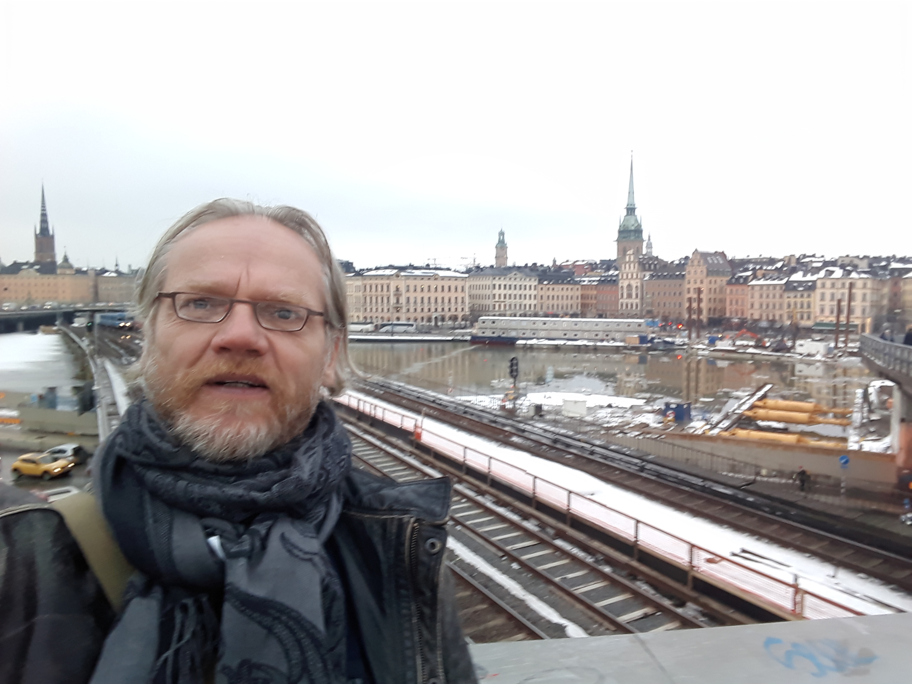

Native language: Swedish
Country of residence: Brazil

Contact:
E-mail: larsgpalmer@hotmail.com
Cellphone: +55 21 988828595
Office: +55 21 41012021
Skype: lars.gosta.palmer
LinkedIn: Gösta Palmér
Translator´s Proz Profile Page: http://www.proz.com/translator/78176
Translator´s Home Page: http://larsgpalmer.wixsite.com/swedish-translator

Languages: - Swedish (native)
- English
- Portuguese/BR – 35 years living in Brazil

CAT Tools: SDL TRADOS 2015 - WORDFAST 3 PRO – MEMSOURCE – MEMOQ (and others)

Services: Translation, editing, proofreading, copywriting, website localization, etc.

Years translating: 27

Academic: 1993 - Universidade Santa Ursula – Rio de Janeiro – Pedagogics;
1992 - University of Michigan – USA – English Proficiency
2014 – CTP – Certified Translation Professional – English<>Portuguese - GTI
2016 – (ongoing) Universidade Cruzeiro do Sul (MG) – Letters Português/Inglês

Rates:
English to Swedish EUR 0.08/USD 0.09
Portuguese to Swedish EUR 0.10/USD 0.11
English to Portuguese EUR 0.07
Swedish to Portuguese EUR 0.10
Portuguese to English EUR 0.07
Swedish to English EUR 0.08

2018/2019 has brought on a wide variety of exciting projects. Here´s a list of the main ones.

- Legind, (150 k source words) – Translation of travel guides to Japan, South Africa, New Zeeland, Portugal, Italy, Canada, Cote d’Azur and Scotland – This was quite a challenge considering the enormous amount of research needed (museums, artifacts, sites, historic events and people involved etc), as well as the limited time available.

- WIX (100 k source words) - A huge undertaking for the WIX webpage generator, which started out with a selection of a team of 20 translators meeting up for a one-week workshop in Stockholm to synchronize and streamline the translation of 2 million words in a mere 2 months.

- OTICON (50 k source words, and counting) - Lots of ongoing work for the Danish hearing aids manufacturer, including product descriptions, user manuals et. al.

- AGA – (50 k source words) - Product descriptions and marketing materials for the Swedish manufacturer and distributor of industrial gases.

The year 2016/17 brought on a wide variety of exciting projects. Here´s a list of the main ones.

- EASY TRANSLATE (60k source words) – Home electronics manuals and product descriptions; Legal tender (7k),
Stand-out appointment: ´LEDNING MED SÄKERHET´ - Workshop in work safety – All course material including Manual, test sheets, assessment criteria etc. (35 K source words).

- AdHoc – (40k source words) – Industrial equipment (heat exchangers and product feeding systems, conveyors)
Stand-out appointment: RENAULT – Automobiles, spare parts, function testing, Service manual for Renault tecnicians

- TRANSLATE PLUS – (30k source words) – marketing, product sheets, employee survey
Stand-out appointment: Trusted supplier of weekly online Gambling/Gaming projects for a number of web sites

- BALTIC MEDIA (40k source words)
Stand-out appointment: Star Tech, IT, home and office electronics, Trusted supplier of weekly product descriptions

- CENTRAL DE TRADUÇÕES (20k source words) – Medical supplies, odontology, product descriptions, user manuals
Stand-out appointment: ANGELUS, product sheets and descriptions, medical and surgical procedures

- POLE TO WIN (250k source words) – Childrens online interactive game
Stand-out appointment: STAR STABLE - Complete game site with item descriptions, complete story line and dialogue, game instructions, regulations etc.

- ZEN BOX DESIGN
Stand-out appointment: Trusted supplier to Zen Box UK client Mathmos Ltd. All web site content for Interior Design products, including the Lava Lamp. Product descriptions and user manual for e-shopping, terms and conditions etc.

- AUDIO PROJECTS
Stand-out appointment: SAPPHIRE - Trusted supplier for adult entertainment including titles and synopses.

- MARKMAAL

- MOELGAARD & NIELSEN
Summary of Main clients and Appointments

CURRENT SUPPLIERS & CLIENTS | SUBJECT AREA | LANGUAGE PAIRS
Translate Plus | Engineering, industrial, marketing, website localization, gaming and online gambling | EN>SE
Ad Hoc | Tourism (Travel guides), | EN>SE
Easy Translate | Web site construction, engineering (Trafikverket) | EN>SE
Word 360 | Marketing, corporate videos | EN>SE
TOLQ | Eyeware | EN>SE
INTO | Technical | EN>SE
Previous suppliers
Dansey and Wesley | Marketing, furniture, sales, product descriptions | EN>SE
Feature subtitling | Television, film, stand-up comedy | EN>SE
UK Techtrans | Engineering, machinery, packaging, aeronautics | EN>SE
Transperfect and affiliated agencies | Marketing, IT, Technical, medical et.al. | EN>SE
Baltiq | Medical: User instructions treatment device | EN>SE
BK Projects | Industrial/Engineering: IT. Software, user manuals for tacograph | EN>SE
CBG | Industrial/Engineering: IT. Automotive, instruction manuals | EN>SE
Certas Palavras (Eurologos Lisboa) | Tourism/Leisure/Travel: Marketing. Golfcourse, condo, investing | PT>SE
Dropet | Industrial, fuels, ethanol exhange platform | EN>PT
ECI | Subtitling, literary. idiomatic | EN>SE
Estilos  Harald Eriksson | Finance/Economy: Accounting, Balance sheet | PT>SE
Eurologos Toronto | Industrial/Engineering: user manuals for dolly base/traverse unit | EN>SE
Global | Industrial, engineering, cooling systems | EN>SE
Letras Language Solutions  (Karin Hallberg & Malin Johansson) | Industrial, engineering, user manuals, marketing, sales, consumer products | EN>SE
Linguavox | IT, marketing, translation services | EN>SE
Comprehensive Book Translation Services  (Matt Sundakov) | Medical, Bronk dilatorer, asthma treatment | EN>SE
MGI | IT, software, help tools, tag editor | EN>SE
Morpheus Travel & Language | IT: Marketing, Online questionnaire
Odilon Louzada | Marketing, user instructions for gift credit card | EN>SE
Originalarn | Legal: contracts | PT>SE
SLTS India | Legal: Contracts | SE>EN
Snabbõversãttare .se | Legal: immigration regulations | PT>SE
Studio Melchior | Industrial/engineering: Medical, user manual for radiation therapy | EN>SE
Traduko  Erik Olsson | Social/Educational: handbook/instructions for special Olympic day in schools | SE>PT
Traduza | Legal: birth certificate | PT>SE
Translation Experts | Engineering/Industrial: Consumer products, user manual, diesel boat  Legal: birth certificates | EN>SE  PT>EN
Translated.net | Marketing: household appliances, brochures, advertising  Literary: Poetry | EN>SE
Xlation language services | Industrial/Engineering: User manual induction motors | EN>SE
Snellversaler | IT: legal, visa regulations | PT>SE

END CUSTOMERS | SUBJECT AREA | LANGUAGE PAIRS
Alexandre Castro Gomes | Children's books – “What, a penguin at the North Pole!”, Monsters´ Condo” | PT>EN
Offside  Swedish sports periodical | Journalism: Sports, football | PT>SE
Marcos Winter (Actor) | The play “Jackets” by Edward Bond
Souza Cruz  Tobacco products manufacturer – Brazilian Subsidiary of BAT – British American Tobacco | Business/financial: tobacco manufacturer, internal long term project | PT>EN
Teligent  Swedish Telecomm company | Telecommunications: Marketing, sales, advertising | EN>PT
Altadena  Brazilian company specialized in the organization of events | Biology, ecology, marine mammals, air-guns, science, research | EN>PT
Izabel Burbridge  Brazilian Ceramist | Handicrafts/arts: Pottery, ceramics, marketing, advertising | PT>SE
Valdir Ramos Jr.  Brazilian Biologist/Scientist | Biology/Zoology: Wild animals, habitat, research, science | EN>PT
LAPD – Latin American Press Digest  Defunct Hong Kong based news agency | Journalism: Economy, finance, current affairs | PT>EN
DRAKEN  Swedish publishing house | Children´s plays. “Resan till Ugri-la-Brek”, “Katter” | SE>PT
Murillo Salles  Brazilian Film director | Literary: Idiomatic, correspondence | PT>EN
Carlos Nejar  Brazilian Author, currently occupying chair #4 in Brazilian Academy of Letters and President of Brazilian Academy of Philosophy | Literary: Prose  Translation of the book “A Idade da Aurora” | PT>SE  PT>EN
Henrik Jõnsson  Swedish Journalist | Journalism: article, literary, idiomatic | SE>EN
Dayse Xavier  Psychologist | Medical: psychology, thesis | PT>EN

Subtitling and Dubbing

- Feature Films
Subtitling of films and live performances (stand-up comedy)
English to Swedish

- Herbert Richers
Subtitling, spotting and marking of films, documentaries and tv series
Dubbing of films, documentaries and tv series
Languages: English to Portuguese
System: Systimes

- VTI
Subtitling, spotting and marking
Dubbing of films, documentaries and tv series
Languages: English to Portuguese
System: Systimes

- Drei Marc
Subtitling, spotting and marking of films, documentaries and tv series
Dubbing of films, documentaries and tv series
Languages: English to Portuguese
System: Systimes

Resume of subtitling and dubbing

ORIGINAL TITLE | PORTUGUESE  TITLE | FUNCTION | RUN  TIME | YEAR  TRANS | CATEGORY | CLIENT
Haunted House | A Casa Amaldiçoada | Subtitling | 82’ | 2002 | Full feature | Drei Marc
Still Of The Night | Na Calada Da Noite | Subtitling | 90’ | 2002 | Full feature | Drei Marc
All Of It |  | Subtitling | 93’ | 2002 | Full feature | Drei Marc
Burke And Willes | Burke E Willes | Subtitling | 121’ | 2002 | Full feature | Drei Marc
Ladies’ Man | O Mulherengo | Subtitling | 30’ | 2002 | Trailer | Drei Marc
Thanksgiving | Ação De Graças | Subtitling | 30’ | 2002 | Mini series | Drei Marc
Death Row | No Corredor da Morte | Subtitling | 30’ | 2002 | Mini series | Drei Marc
Gung Ho | Batalha Final | Subtitling | 92’ | 2002 | Full feature | VTI
Sundown | Entardecer | Subtitling | 87’ | 2002 | Full feature | VTI
Algiers | Argélia | Subtitling | 89’ | 2003 | Full feature | VTI
Angel on my shoulder | Um Anjo Na Minha Vida | Subtitling | 91’ | 2003 | Full feature | VTI
Ernesto CHE Guevara | Che | Subtitling | 92’ | 2003 | Documentary | Herbert Richers
Devil Bat | O Vampiro | Subtitling | 77’ | 2003 | Full feature | VTI
Cyrano de Bergerac | Cyrano De Bergerac | Subtitling | 113’ | 2003 | Full feature | VTI
The Rise of Katherine the Great | A Rainha Imortal | Subtitling |  | 2003 | Full feature | VTI
Sophie’s Choice | A Escolha De Sophia | Subtitling | 33’ | 2003 | Part of Full feature | Herbert Richers
A Farewell to Arms | Adeus às Armas | Subtitling | 85’ | 2003 | Full Feature | VTI
Cry Freedom | Um Grito de Liberdade | Dubbing | 145’ | 2003 | Full Feature | Herbert
Saturn 3 | Saturno 3 | Dubbing | 90’ | 2003 | Full Feature | Herbert
Mandela & Klerk | Mandela & Klerk | Dubbing | 90’ | 2003 | Full feature | VTI
Flying Deuces | Tolos Voadores | Subtitling | 75’ | 2003 | Full Feature | VTI

