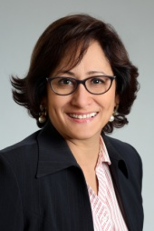
Editorial Brief - Neena Kiss
Email: neenakiss1@gmail.com

5+years in subtitling/translation and QC ENGLISH/HINDI
Typing speed 328 CPM / 66 WPM. Score in top 20percentile of online test.

PERSONAL DATA

Born: 1973
Resident of: Germany
Language skills: English-Native
Hindi-Native
Marathi-Fluent
Konkani-Fluent
German – Intermediate
Other achievements:
Netflix's Hermes Hindi test - 87.33%
Netflix CQC Verifier – final check before asset goes “live.”

PROFESSIONAL EXPERIENCE

FCI Multiple Services Jun 2019-Present
Translator/QCer
Sub-techs May 2017- Present
Subtitler/Translator
VSI (Netflix Preferred Vendor) Mar 2017- Present
CQC Verifier
Tekom Vertalers BV Jul 2017-Present
Subtitler/Translator
VDMS LONDON/USA (Netflix Preferred Vendor) Sep 2016 – Present
Subtitler/Translator
Sferastudios Jan 2014-Present
Subtitler/Translator
Deluxe Digital Studios May 2013-Present
ENG Subtitler

Corporate Career 1997 – 2011
(Idea Cellular, HDFC Bank, IndusInd Bank, Capvent) Duration: 14 yrs

ACADEMIC CREDENTIALS

1996 Master of Arts Deccan College-Deemed University
1994 Bachelor of Arts Fergusson College, Pune University

