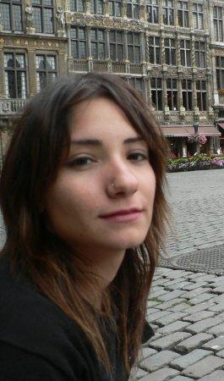

Eylül ERTEN

Kumrulu Yokuşu 28/4 Cihangir

Beyoğlu/İSTANBUL

Cep: 0535 255 94 33
E-mail: eylulerten@gmail.com

EDUCATION

2002–2008 Gazi University Faculty of Economics and Administrative Sciences Labor Economics and Industrial Relations
1999–2002 TED Ankara College Foundation High School
1991–1999 TED Ankara College Foundation Primary School
1989–1991 American Preschool Ankara

SKILLS
Foreign Languages English: Advanced
- Speaking, Writing, Reading: Advanced

French: Beginner
- Speaking, Writing, Reading: Beginner

Computer Skills Microsoft Office; Word, Access, Excel, PowerPoint, Adobe Photoshop, SmartCAT, Monalle

EXPERIENCES

2003-… Freelance Translator, English – Turkish / Turkish - English Translation, Localization, Transcription, Subtitling, Transcreation.
Excellent English speaking and writing skills. Translation of articles on entertainment, marketing, cultural, advertorial, educational, general, medical and technical areas. Translating TVCs, corporate films, advertising documentaries, and other audio and visual captions for the marketing industry. Operating computerized captioning system to provide subtitles. Localization of S/W products and web sites on various areas’ adverts. With the transcreation services I provide, I ensure your global brand campaigns remain consistent.

Brand the Bliss Advertising Agency Senior Copywriter
November 2015 - ........
Creative ideas & copywriting all the printed and digital materials, transcreation and creation of creative campaigns for global brands like Shell, Schwarzkopf, Yeni Rakı, Mey Diageo, A.O. Smith, Smirnoff, Microsoft, Xbox.

Kuartet Advertising Agency Senior Copywriter
November 2014 – November 2015

dDf (dream Design Factory) and
iDf (International Design Fairs)
November 2013 – November 2014 Copywriter& Editor

Corporate printed/digital texts, translations, invitations, catalogues, booklets; editing, proofreading, event naming, concepting and slogans; writing of event materials.

The Adquarters Advertising Agency Copywriter & Editor
November 2013 – November 2014 Managing creative processes of advertising campaigns, creative writing, TVCs scripts, print ads, writing every advertising material due to the campaign concepts, printed/digital texts, translations, invitations, catalogues, booklets, advertorials in both digital and conventional advertising principles; editing, proofreading, event naming, concepting and slogans
Mekanist Freelance English Writer, Editor - Turkcell IOS/Android App about İstanbul’s historic places.
December 2013

March 2013- December2013 Faros Hotel and Restaurants / Efes Sports Pub Advertising,Social Mediaand EventDirector, Copywriter

- In house advertising campaigns in both English and Turkish and directing all advertising processes of the hotels and restaurants.

October 2010- March 2013 İstanbulMESE PR Company, Editor, Writer

- Writing of press materials including corportae invitations, press releases, annual reports etc.
March2010-August 2010 Ankara Leo Organization and Communication,Editor, Social Media Expert, Writer
Ankara Leo Marketing, Durance, Editor
Ankara Leo Marketing,Web Editor
Aralık 2009 Leo Organization, Ankara Jazz Association,Translator, Editor

PERSONAL INFO

Nationality : T.C

Birth Place : Ankara, TURKEY

Birth Date : 01.11.1985

Marital Status: Married

