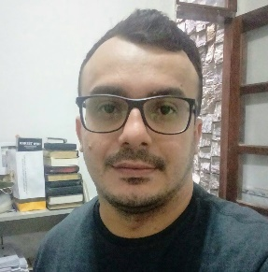
RÉSUMÉ
Paulo Dhiego Oliveira Bellermann
Nationality: Brazilian; Marital Status: Single; Born on: May/07/1983; Natural of Mossoró/RN (Brazil)
Address: Rua Venceslau Bráz, 505 - City: Mossoró-RN (Brazil)
Phone: +55-84-988982836 (Oi / WhatsApp)
E-mail: paulodhiego@hotmail.com - paulobellermann@gmail.com
OBJECTIVE
To develop a function in the esteemed institution aiming to develop an activity that provide a better quality of products or services offered by the company.

EDUCATIONAL BACKGROUND
High School
Institution: Redlands East Valley High School (High School Abroad)
City: Redlands - California (USA)
Institution: CEJA Prof. Alfredo Simonetti (General Equivalency Diploma in Brazil)
City: Mossoró - RN (Brazil)
Technical course
Institution: Redlands-Yucaipa-Colton ROP
Course: Pharmacy Technician
City: Redlands - California (USA)
Higher education
Institution: Crafton Hills College (Incomplete)
Disciplines: Speech 101; Spanish 101; English 094
City: Yucaipa - California (USA)
Institution: UERN - State University of Rio Grande do Norte
Course: English (Language and Literature)
City: Mossoró - RN

PROFESSIONAL EXPERIENCE:
- Company: Self Employed
Job position: Freelance Translator - 2009 to present
City: Mossoró, RN
- Company: Colégio Diocesano Santa Luzia - CDSL
Job position: English Teacher - 2017
City: Mossoró, RN
- Company: Fisk – Centro de Ensino
Job position: English Teacher - 2015 to 2016; and 2018 to present
City: Mossoró, RN
- Company: Skill Idiomas
Job position: English Teacher - 2012 to 2014
City: Mossoró, RN

Sincerely,
Paulo Dhiego Oliveira Bellermann

