Curriculum Vitae 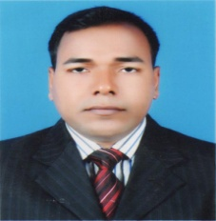
Of

MD. SHARIF
Contact number: +8801715429300
E-mail address: shariflec14@gmail.com

Academic Background

Exams | Discipline | Name of the Institutes
B.A(Hon’s) | English | Dhaka International University
M.A | English | Dhaka International University

Working Experience

- Professional experience in online interpretation, translation, subtitle from English to Bengali as a native Bengali translator.

- I enjoy reading other subjects including social sciences, law and business fields.

- Have previously translated industry reports, articles, and other fields with high confidence.

