Chloe Na / KyungWon Na
English to Korean Translator (Native Korean)
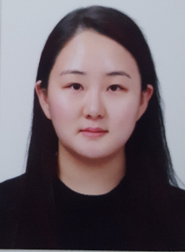
Don’t hesitate to contact me anytime (24/7)
- Phone: +82)10-3785-3583
- Email/Skype/Paypal/Facebook Messenger: EnKrTranslatorChloeNa@gmail.com
- Line/KakaoTalk ID: peaceandbalance
- Proz.com profile: http://www.proz.com/profile/2631809 (Plus Member)

Work History
- Game:
- Witchit (simulation, 2619 words)
- Aniscience (education,7320 words)
- Rubik 1d (puzzle)
- Addition and digits for kids (education,160 words)
- Localization
- GPG Real-time multiplayer connection speed test app

Areas of Expertise
- Game: Mobile, Video Games, Simulation, Puzzle, etc.
- Cosmetics: Skincare Products, Makeup Products and Tools, etc.
- B.A. in Interior Design: General Floor Plan, Interior Accessories, Lighting, Furniture, Kitchen Utensils, etc.
- Travel, Pet, Food and Beverages, Fashion, Luxuries, etc.

Technical Skills
- Cat Tool: SDL Trados 2019 Freelancer, SDL Multiterm 2019, MemoQ 8.4, Wordfast, Memsource, Wordbee
- Computer skill: MS Office, Excel, Word, Hangul, Adobe, Wordpress, Powerpoint,
- Design Skill: Photoshop, CAD, Paintshop Pro, SketchUp

Rate
- Translation: $0.04~ per word
- Proofreading: $0.02 ~per word
- Word Capacity: 4000 words per day

Education
- BA in Interior Design, Yonsei University, Korea

Hobby
- Weight lifting, Running, Swimming

