İlker ÇAPRAZ

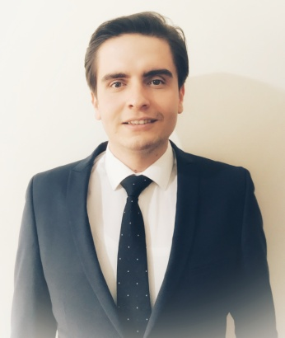

Ceyhun atıf kansu 1261 street 4/8
caprazilker07@gmail.com
TEL : 0534 237 15 08

Personal  Information | - Employment Status: Working  - Educational Status : University (Date of graduation : 07/07/2017)  - Marital Status : Single  - Nationality : Republic of Turkey  - Date of Birth : 29/04/1993  - Place of Birth : Turkey-Antalya  - Driver’s License : B-A2 (06/06/2012)  Professional Skills Summary  - Entrepreneurial spirits  - Continuous improvement  - Open to learning  - Energetic  - Having a tendency to work with group  - Easier adaptability  - Professionalism and work ethic  - Effective communication and researcher
Education | University (Bachelor’s Degree): Ankara Yildirim Beyazit University (AYBU)  (Faculty of Political Sciences, International Relations) 2.78/4.00  High School : Alanya Ufuk Anatoian High School 86.43/100
Skills | Language Skills  English : Advanced  German : Basic  Sport Skills  Football  Ping Pong  Pool and Billiard  Freestyle Combat  Computer Skills  Microsoft Office 2007,2010; Word, PowerPoint, Excell, SDL Trados 20014 2015 2017
Certificates | Personal Development and Diction  April 2016  African Schools Seminars  May 2017  Leadership&Motivation  October 2015
Experiences | Short term summery work experiences:  - Palmiye Optik Alanya (03.07.2012-09.09.2012)  - Dim Cave Alanya (25.06.2014-05.09.2014)
Additional | Hobbies  Cinema, Theatre, Swimming  Formun Üstü  Formun Altı
References | First Name Elvan  Last Name SUNGUR  Phone Number +90 533 956 75 71

