|  |  |
| --- | --- |
|  | Simone Bernardo Valiceli |
| C:\Users\Simone\Documents\CURRICULOS\CURRÍCULOS SIMONE\Camp 1.jpg | Freelance translator  english - Portuguese  (BRAZIL) |

272 João Cavinato street – downtown

São Bernardo do Campo – SP – Brazil

Civil status: widow

Cell phone: +55 (11)9.6581-6441

e-mail: sbvaliceli40@gmail.com

Academic background

● High School – EEPG Maria Trujillo Torloni

● College Degree – English and Portuguese Languages and Literatures – Anchieta College (2010)

● English Course – CLA – Anchieta Languages Center - (Certificated in 2010)

● English Course – PBF Languages School – Advanced English (Certificated in 2014)

● Graduate Studies – Translation English to Portuguese (current; started in 2019)

extracurricular activities

# **Resultado de imagem para editora unespportuguese Grammar for reviewers**

# professor Ibraíma Dafonte Tavares

UNESP – Universidade do Livro (Book University from São Paulo)

Conclusion: August 28, 2018.

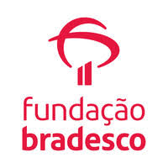 **PORTUGUESE LANGUAGE COURSE**

Conclusion: April 21, 2019 – 40 hours.

**PORTUGUESE LANGUAGE GRAMMAR WITHOUT COMPLICATIONS**

Conclusion: March 28, 2019 – 20 hours.

**WRITTEN COMMUNICATION**

Conclusion: February 26, 2019 – 16 hours.

 **English Grammar and Style UQx: Write 101x – Edx Courses**

Conclusion: December 09, 2017 – 52 hours.

**Technical Translation Market and SDL Trados Studio**

Geronymus courses and business training

Conclusion: June 12, 2017.

**Workshop Reading and Writing in Portuguese – Classroom training**

**Anchieta College –** conclusion: June, 2009 / 180 hours class load

Professor Miriam Fernandes.

COMPUTER SKILLS

- Office Package Windows / Google - MemoQ - Mate Cat - SDL Trados Studio 2017

Professional background

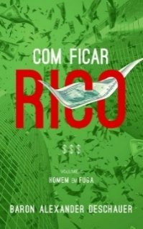**● Freelancer Translator (see the author comments and rates)** 

**Profile:** <https://www.babelcube.com/user/simone-bernardo-valiceli>

**Published Book:** "How to get Rich" – Baron Alexander Deschauer

**Translated into Portuguese Language (Brazil) – "Como Ficar Rico"**

**● PBF Languages School**

**English Teacher**

Started Aug. 13, 2014 – current. I teach English on Saturdays.

**● Empresa: Piaget School - SBC**

**Coordination Assistant of Elementary School**

Started Apr. 16, 2015 – current.

**● J. Piaget Multimedia Educational System (Piaget School - SBC)**

**Coordination Assistant** – from Jan to Oct, 2009.(I left this job due to health care of my husband)

Main responsabilities: Research and preparation didatic material.