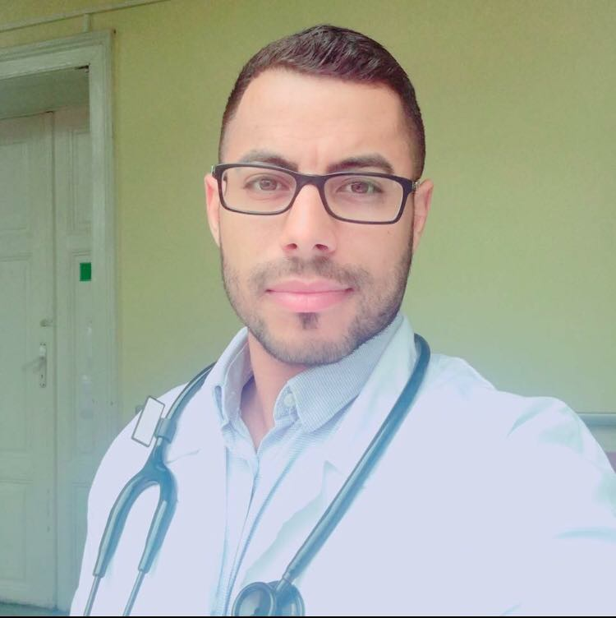 |  | Salleh Byan  Translator
Profile  Contact  PHONE:  0046769040272  EMAIL:  Dr.hiebb@gmail.com |  | EDUCATION  SEMMELWEIS UNIVERSITY  Medical student 6th year  WORK EXPERIENCE  I worked as a translator for a year now, I got skills on translator many languages.  I'm multilingual speaker, i can speak 6 languages, 3 of them are eloquently which are: 1) English 2)Arabic 3)Hebrew The rest 3 languages are well spoken, which are: 4)Italian 5)Swedish 6)Romanian.  *About me  - I am able to handle multiple tasks on a daily basis.  - Creative. I use a creative approach to problem solve.  - I have experience working as part of a team and individually.  Even though I take my work seriously, I do have a good sense of humour.  SKILLS  Two Native Languages:  1) ARABIC 2) HEBREW  Fluent Languages:  3) ENGLISH 4) SWEDISH 5) ROMANIAN and ITALIAN

