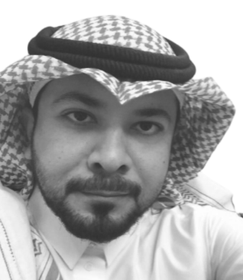
RAYED ALSHUQAYR
English Language Teacher

Profile
(Contact information) The only field that has never failed to interest me was and will always
be “Language”. I’ve been nothing but enthusiastic to teach, learn
Address: facilitate and interact, all within the realm of English Language for
Ha’il, 55421, Al-Wusayta 7972 many years. That being stated, I’m still eager to discover the promised
land, for I’m sure that I still haven’t reached my potential.
Phones:
+966564818037
+966503995043 Career
(2006 – 2018) English Language teacher at secondary school level .
(2018 – 2019 ) Student and teacher at Kansas State University. Part of
E-mails: The Exchanging Experiences Program.
raed.7.911@gmail.com (2019 – Present) English Language teacher at secondary school level.
c.lupus.1983@gmail.com
Skills
- I Can adjust to any given environment as long as I excel and influence.
- With my pedagogical background, the process of teaching and/or
learning are instinctive to me. Patience is a virtue that guides me
while seeking perfection at any given task.
- I’m a fluent speaker who seeks improvement at any given chance.

