ROGER RAYNER, MA, AITI
Art in other words

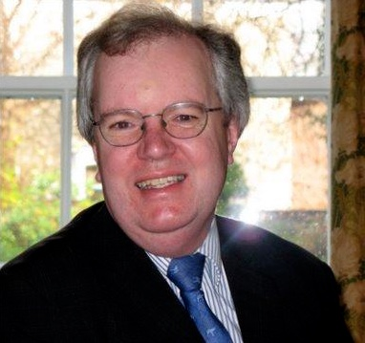
90, Buxton Road, Aylsham, NR11 6UB, UK

+44 7497 356501
Email: roger@weaverswaytranslation.co.uk
Website: http://www.girolamofantini.com
Proz.com Profile: http://www.proz.com/profile/617180
LinkedIn: www.linkedin.com/in/roger-rayner-935a0a73

German to English/French to English Translation: Automotive and Rail| Architecture | Art | Culinary | Music | Travel and Tourism | MTPE
Key Services: German to English Translation
French to English Translation
Equipment/Software: macOS Mojave and Microsoft Office 10, Windows Word, Excel, PowerPoint, memoQ 9.2, WordFast, CafeTran Espresso, Sibelius, Final Cut
Rate per word (source): £0.10
Rate per word (editing): £0.05
Education
1981 MA, Trinity College, Cambridge, UK
1978 Royal Academy of Music, London, UK
1974 Exhibition, Trinity College, Cambridge, UK
Experience
2015-present Full-time translator
1978-present Musician, pianist, organist, teacher, p/t writer and translator
1994-2000 Course Director with leading educational travel firm
1998-2000 Tutor: Cambridge Board of Continuing Education
2000-2013 Visiting Tutor: University of East Anglia
To view a mini-tutorial on a piece of organ music, please click on the link:
https://girolamofantini.files.wordpress.com/2020/04/roggtoccatacommentarypart1-1.mp4
Translation Experience and Areas of Specialization

2015-present Specialities: Travel and Tourism, Architecture, Art, Music, Culinary, Automotive and rail, MTPE
Professional German-English and French-English translations for arts organizations and publishers, using skills in the areas of project completion, quality assurance and communication, demonstrated by 40 years of teaching, performing, writing, lecturing, tour guiding, and conference chairmanship.
Reviews and articles for Country Life, Musical Times, Music and Musicians, Organists’ Review.

1994–2000 Course Director
Directed educational tours to major German and Austrian festivals
Acted as German interpreter on guided tours and as a goodwill ambassador
Demonstrated historic pipe organs and other keyboard instruments formerly played by Bach, Haydn, Liszt and Brahms

1998–2000 Tutor: Cambridge Board of Continuing Education
Devised courses on French and German music for adults at Madingley Hall
Introduced high school students from USA to university lecturing

2000–2013 Visiting Tutor: University of East Anglia
Freelance translator of French and German
Language Proficiency
English Native language, excellent command of written and spoken English, especially academic English
German Very good reading command of German, especially literature, music and architecture, assessed as natural speaker
French Very good reading command of French, especially literature and music
Sample translations
A representative sample of translations is available on my profile pages at Proz.com http://www.proz.com/profile/617180 or click here: https://www.proz.com/settings/history?eid_s=617180
Additional training and experience

2005-present Corresponded with and visited prisoners on death row in Zambia
2015-present eCPD and ProZ.com webinars, latest including Art, Architecture, Rail, Travel, Gastronomy
2018-2020 CPD Certificates from ITI, 2018-19; 2019-20
Memberships
Associate of the Institute of Translators and Interpreters
Royal Academy of Music Club; Gesellschaft der Orgelfreunde; Österreichisches Orgelforum
Hobbies

Baking and serving Austrian cakes and coffees; walking; travel; friendships in Zambia
References:

Margarita Gess margarita@alchemytranslations.com
Caterina Fedrigucci cfedrigucci@eurotrad.co
Dirk Ceelen dirk@dice.be

