Yoshiyuki Yamamoto
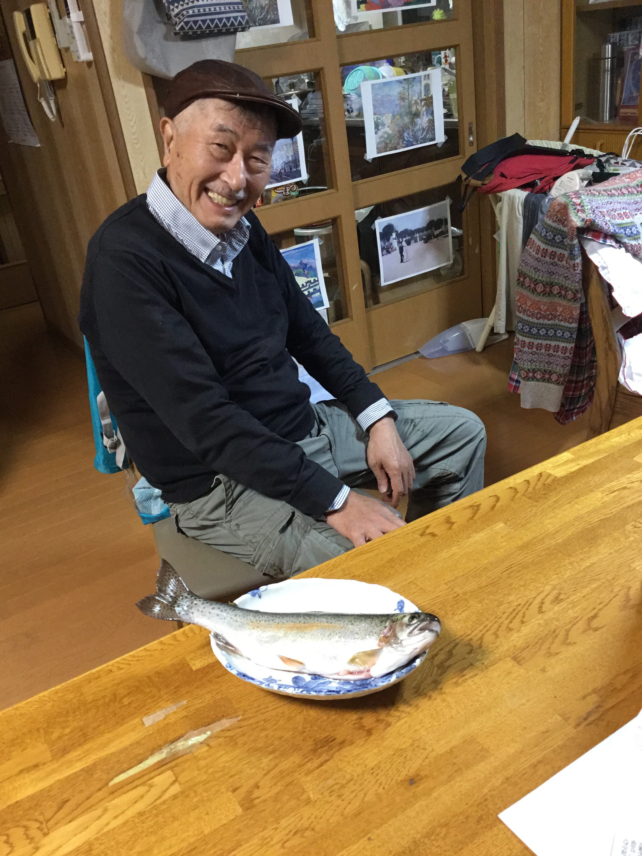

Born on Nov. 20, 1943, Age 74

Domicile:
1-7-32-18 Fujino Minami-ku Sapporo
Hokkaido, 〒-061-2281, Japan

FAX: 81-011-591-6030 Portable: 080-9100-3756

Email: yyoshiyam@ae.auone-net.jp

History:
Graduated from Hokkaido University in March 1968, with a bachelor’s degree of Architectural Engineering
Entered Nippon Steel Corporation Co. LTD
Retired in Jan. 2004
After retirement: Working as a freelance translator of F-J, E-J, and J-E translation specialized in technical matters over 13 years up to now.

Experiences:
Plant Engineering (Conception, Design, Construction and Maintenance) in integrated steel making plants
Software development (CAD/CAM included)
Sales and R&D in urban exterior products
Production management of foundry products for urban exterior

Qualification: Certified Architect/Engineer (Major License)
Others: French intensive course at the Institute de La Rochelle in France for 6 months, 1978.
CAT tools: Trados Studio 2017

After retirement: Freelance translation:
Mainly in English to Japanese and French to Japanese, but also Japanese to English
Domain: Steel Making Engineering, Mechanics/Electronics/IT communication/Chemistry/Medicine/Pharmacy/Construction
Genre: Patent papers/ Technical documents/papers/ reports/specifications/manuals
Contract/business documents

