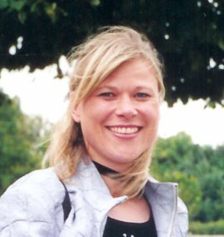

Stina Stubkjær Jensen

Ageren 17

4700 Næstved

Denmark

Home telephone: +45 86222696
Mobile: +45 20848108
E-mail: usdanedk@gmail.com

Nationality Danish (parents American)
Date of birth 13 November 1968

- Translating - Danish to English and English to Danish
- Clients have included: Deakin University, Damatech, Maersk, Central Soya, Adidas, Scandic Hotels, Dafa, BASF, Radartronic, Danisco, Danfoss

Projects include:
- Patents – patent abstracts for the EU patent database
- Websites – translations from English to Danish and Danish to English, localisation and advisory services
- Technical translation –corporate security and classified information
- Financial translation – accounting, annual reports and corporate finance
- General translation – press releases, news summaries and certificate translation

Professional Experience

2006 to 2011 Continuation school teacher, Nysted Efterskole, Denmark
Taught English, History, Politics and Religion.

1998 to 2005 Freelance translator/ language instructor
Translation from Danish to English and English to Danish.
Teach business English and Danish to groups and individuals at corporations; topics include technical English, translating of manuals, small talk, telephoning.

1998 to 2000 News editor/journalist, Daily Titan, Orange County, California
Investigating, reporting, writing, and proof reading of stories for daily newspaper.

1998 to 2000 Teaching assistant
Preparing and teaching classes of 125-200 students in American Politics and American Politics and Film. Corrected essays for grammar and content and graded them.

1997 Customer service assistant
New home builder, in charge of diary for 7 in-field constructors, billing, filing of claims, legal matters.

1995 to 1997 Reporter/production assistant/assignment desk assistant
Selected stories to research, carried out interviews with major Hollywood stars and in charge of copy for news anchors.

Education

Master Degree in Political Science
California State University, Fullerton
Fullerton, California
May 2000

Bachelor Degree in Journalism and Political Science
University of Southern California
Los Angeles, California
December 1996

Associate of Arts Degree, Journalism
Orange Coast College
Costa Mesa, California
December 1994

Handelshøjskolen i Århus
English/French interpreter
Finished 4 courses
August 1990-October 1991

Computer skills

- Word Perfect
- Excel
- Windows
- Microsoft Word
- Photoshop
- Dreamweaver/Frontpage
- Quark

