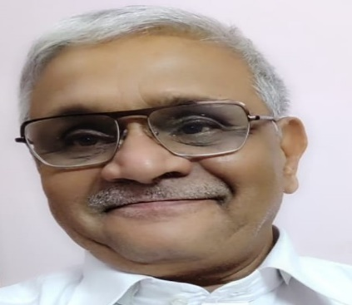

KRISHNA KALYAN KULKARNI

(Kannada Linguist & Localization expert)

ABOUT ME

Name Krishna Kalyan Kulkarni
E.mail krishnakalyankulkarni@gmail.com
Work Telephone +91 8978994340
Skype: krishnakalyan2
Address Ramantpura, Hyderabad-13 (Telangana)
Nationality Indian
Mother tongue Kannada
Languages known Kannada, English, Hindi, Marathi, Telugu
Birth year 1951
Experience 12+ years
Work objective I exist to deliver superior Customer Experience by continually
Simplifying Translation Processes and creating Sustainable Value
for all stakeholders Customer satisfaction, Up hold my mother
tongue dignity, essence & greatness.

Translation English > Kannada (specializations, all subjects)
Marathi > Kannada (Seldom, all subjects)
Hindi > Kannada (Seldom, all subjects)

Domains I specialize in UI, advertising, environment, Social science, politics, Art & culture travel and banking translation and Medical related subjects like ICFs, patient diaries etc.I am working on various domains such as Agriculture, Medical,
Technical, Sales, Advertising, Insurance, Banking, Educational,
Legal, Commerce & Economics computer, UI etc.

I worked with an enormous diversity of clients, performing PR duties, and developed strong relationships with many of the region's leading publishing houses, writing ad-hoc features covering business, travel, health, sport, art and lifestyle etc. while ensuring clarity and grammatical accuracy.

My E.Patrons: * Moravia, ∗ Yahoo, ∗ Vistatec, ∗ Welocalize * Go-transparent,
∗ Andover ∗ Braahmam ∗ Gem Translators, ∗ Venchars,
∗ Honyaku remedies, ∗ Green Language Service, ∗ Crystal Hues,
∗ Nihon iPrism, ∗ Vie, ∗ Cosmic Global, ∗ Six Sigma Bio-solutions
∗ Earth Lingua, ∗ Eldorado, * Swan, ∗ Yashvi, ∗ Bull fish ∗Alfa tech-egypt * Derby Translations UAE * Siddhant * Lingo Canada, Soumya
* Beno *LangScape *Perfect *Swan & many more . . .

Operating CAT:: XTM Cloud, Symfonie, Smartling,prabandhak, MemoQ. MS Excel, MS Power Point, MS Word, SmartCAT. GTT.Smarling.Wordbee etc

Kannada Tools • Baraha • I.Lip • Nudi, • Sri Lipi (both ANSI & Unicode)

Formal Education & Experience (other than above)
- Graduate in Commerce
- Diploma in journalism
- Diploma in Printing & Publishing
- Worked as an Asst Editor for Local Kannada papers/Magazines
- Worked as a Mg.Director to a Manufacturing Pvt. Ltd. Company
- Adviser to Local Kannada E. Learning Companies
- Member of Editorial Board for many Religious & Social periodicals

For your kind information:
- I am a Kannada Linguist - work Full-Time from my home office. Hence always easily available.
- My many years in this field and my abundance of work, education and cultural experience have given me unique and complex insight in to Kannada language which I apply to all my translation specialty area. I am skilled in multiple subjects, which is seldom in the translation trade.
- I have contracts and contacts with dozens of Indian and abroad translation agencies. I am a member of ProZone, Translation Directory, Linkedin, Voice-heard, Translators Town, Translators Pub, Freelancer, Tradeguide work, ITC International Translation Club etc. & regularly getting co-operations from all of them
- I am always open to additional co-operations with new agencies and language professionals.
- On free days and in empty hours I normally love to spend my time to update my knowledge and study more for its application to different fields.

