 | Curriculum vitae
20/04/2010
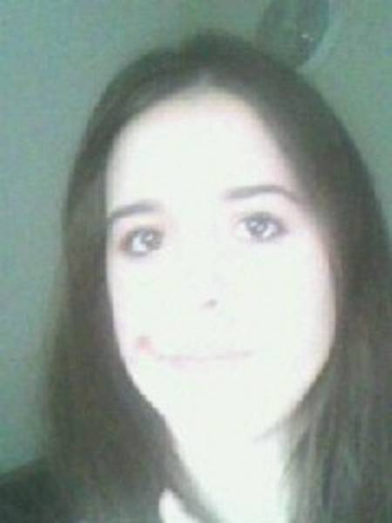 | 12 rue des lavandières 61130 La Chapelle souef  France  gwendoline.soleau@yahoo.fr

TRANSLATION/PROOFREADING FIELD
Sport, Education, literary, biology, history, travel
TRANSLATION PROCESS
To translate I use principally my dictionary and my own knowledge of the language
USING SOFTWARE
Dictionary
Language TRANSLATE/PROOFREADING
Finnish , English, Icelandic, German, French, Norwegian
Travel
Three months in Helsinki, two months in Oslo
Reference letter
I am a first year student of biology at the University of Maine at Le Mans I'm looking to do translation work. I want to multiply the opportunities and experiences to expand my field of expertise and my future opportunities in working life. Passionate about everything concerning the nature and chemistry, I would turn towards the environment, sustainable development.

Payment method
Paypal
Rate
0.05 usd per word

b

