Muhammad Ikram  Urdu Consultant, Localization Expert  (10+ years of professional experience)  +923112127744  ikram.bhullar@gmail.com  https://www.linkedin.com/in/mohammad-ikram-34386936/  Islamabad, Pakistan | 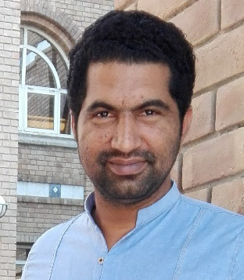

Languages  Punjabi Native  Urdu Native  English Excellent  CAT and PM Tools  SDL Trados Studio  Microsoft’ Loc Studio  Google Translation Toolkit  Twitter Translation CAT  Facebook CAT  Moravia’s Symfonie  Welocalize Vendor portal  LionBridge’s Gemini  Skills  Translation  Localization  MTPE  Voice over  Subtitling/CC  Linguist Trainer  Project Management | Recent  - 2018 – 2020 Urdu Language Consultant at FACEBOOK APAC Was responsible for maintaining quality of all Facebook products in Urdu, coordinating, and liaising with vendors for guidance and necessary training. Led the vendor teams and helped them fix issues across all Facebook products which improved user experience considerably and made them more accessible and user friendly  Previous  - 2010 - 2011 - 2011 – 2012 Human Rights Commission of Pakistan (HRCP) I was editor of Monthly magazine of HRCP Target Language Expert at AVANT ASSESSMENT Being a TLE my work included creation of authentic (culturally and linguistically valid language) passages both in written and spoken language.  - 2012 - 2015 Localization of Microsoft Products Worked on the localization of Microsoft Products, Windows 8 and Office 365 as a freelancer translator with several agencies  - 2015 - 2018 Team Lead for Google Product Localization Led three teams for Google Product localization, Product quality was below required threshold when I joined but under my leadership, quality went up to 100% from below 90% and remained 100% for three consecutive years. My work was presented as a success story in one of the presentations at Google HQ.
Major Clients
Before joining Facebook, I worked as a freelance translator, Interpreter, localizer and reviewer for over 10 years. Few names are: RWS (Moravia) , Welocalize, Lionbridge, SDL, Kantar

