 | Sara Winge  Address: 515P Jalan CM Hashim,  Tanjong Tokong, Penang 10470  Phone: 0125063053  E-mail: sarawinge@yahoo.se | 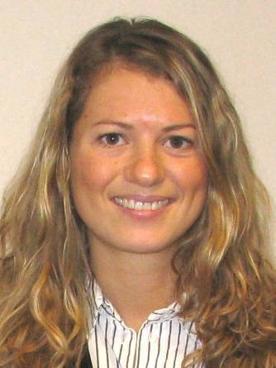

Curriculum Vitae

Work experience
- Wine and Spirits, Stockholm, 2000-2002
Accounts assistant. In charge of payments to the international wine and spirit producers and to the Swedish clients.

- International brands (Affiliate to Wine and Spirits), Stockholm, 2002-2003
Sales assistant. Worked in a team of four people in charge of the sales of spirits in South America, the UK, Canada and Asia. Preparing power point presentations, accounting, marketing events, customer service, client support, developing of new order platform for distributers of the brand DANZKA Vodka. Working close with affiliate in Denmark.

- The Absolut Company (Absolut Vodka, Affiliate to Wine and Spirits), Stockholm, 2003-2004
Sales assistant. Booking and planning of trips, accounting, filing, administration, events and exhibitions in Sweden and internationally. Customer support and client support, tracing of fake bottles. Sale support of ABSOLUTE Vodka in Latin America, Canada, the Caribbean, Scandinavia and the UK.

- La Paloma Bar & Restaurant, Malaga, Spain 2006

- Vino Mio Restaurant, Malaga, Spain 2007

- Sol Oliva, Spain 2007
Translation of publicity and information, English-Swedish

- Akademibokhandeln (Book shop), Stockholm, Sweden 2007
Sales

- UNICEF, Stockholm, Sweden 2007
Sales

- DHL, (Cargo), Stockholm, Sweden 2008
Reception

- Logica, Stockholm, Sweden 2008
Project in building hand computers for the local busses and trains.

- Twilfit, (Clothes store) Stockholm, Sweden 2008-2011
Sales

- Niyama Yogastudio, Stockholm, Sweden 2010-2011
Yoga teacher

- Inner Peace Yoga studio, Penang, Malaysia 2011
Yoga teacher

- Yoga Plus, Penang, Malaysia 2011
Yoga teacher

- Freelance Yoga teacher, Penang, Malaysia 2011

University
- Herbal medicine, Linné University, Sweden 2011.
- Diet, nutrition, health, Linné University, Sweden 2010.
- Cognitive Psychology, Mitt University, Sweden 2010.
- Complementary, alternative and integrative medicine, Karolinska Institute, Sweden 2010.
- Natural medicine, Karolinska Institute, Sweden 2010.
- Pathology, Dalarnas University, Sweden 2009-2010.
- Nutrition, Dalarnas University, Sweden 2008-2009.
- Basic medicine, Kristianstad University, Sweden 2007-2008.
- Spanish, Escuela Oficial de Idiomas, Spain 2006.
- Spanish, Malaga University, Spain 2005.
- Economy and marketing, IHM Business School, Sweden 2004.
- Sociology, Stockholm University, Sweden 2002.
- Highschool, exchange program, USA, 1997-1998.
- Social studies and economy, high school, Sweden, 1995-1999.

Courses
- Yoga Teacher Training, SKY International certification, Sweden 2010-2011.
- Agama Yoga, Step 1, Thailand 2007.
- Project leader course, Sweden 2003.
- French, IF Alpes, Annecy/France, 2004.
- English, Bryant College, Boston/USA, 1996.

Languages
- Swedish, native language.
- English, fluent and excellent skills in both speaking and writing.
- Spanish, fluent in speaking and writing.
- German, basic knowledge, 5 years studies.

Other
- Experience and good skills in Office
- Drivers license

