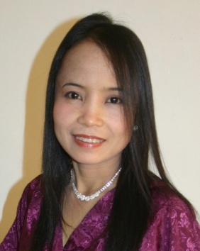

Loida Sangco Clintbell

Contact details:
Mobile telephone number: (+63)920-590-7432 / (+63)917-449-9848
Email address: loi@clintbell.se
Postal address: 5 Westville, Naval Rd., San Miguel
5300 Puerto Princesa City
Philippines
Personal Information:

Age: |  | 43
Sex: |  | Female
Height: |  | 4’11”
Weight: |  | 40 kls
Civil Status: |  | Maried
Birthdate: |  | January 1, 1970
Birthplace: |  | Sibalom, Antique
Citizenship: |  | Filipino
Father's Name: |  | Marcelo F. Sangco
Mother's Name: |  | Merlinda N. Sangco
Skills: |  | Singing, Teaching English Music and Math
Hobbies: |  | Listening Music, Singing, Cooking, Reading
Languages or Dialects: |  | English, Tagalog, Hiligaynon
Emergency Contact Name: John Clintbell
Relationship: Husband
Emergency Contact No: (63)0918-424-5473
Passport No: XX 3957153
Issue Date: June 15, 2009
Expiry Date: June 14, 2014
Career objective

To obtain a position that will enable me to practice my profession, educational background, and develop ability to teach well. To excel in my field through hard work, research, skills and perseverance. To serve people with the best of my abilities.

Employment history
LC’s Gourmet Restaurant
Puerto Princesa City, Phils.
Manager/Owner
February 2012 to the present

The First Galleon Fund Mgt. Corporation
Antique Center, Phils.
Head
January 2004 to January 2011

Galleon Beauty Salon
San Jose, Antique, Phils.
Manager/Owner
November 2007 to November 2009

Calategas Elementary School
Department of Education
Narra District, Narra, Palawan, Phils.
Elementary Grade Teacher
December 1993 to August 1998

Aramaywan Primary School
Department of Education
Narra District, Narra, Palawan, Phils.
Elementary Grade Teacher
July 1991 to December 1993

Education
Tertiary: University of Antique (formerly Polytechnic State College of Antique)
Sibalom, Antique, Phils.
Bachelor of Science in Elementary Education
1987-1991

Secondary: Pis-anan National High School
Sibalom, Antique
Graduated as First Honorable Mention
1983-1987

Primary: Pis-anan Central Elementary School
Sibalom, Antique
Graduated as Second Honors
1977-1983

References:
Jocelyn Morales
Dean BSBA- DL Dept.
University of Antique
Sibalom, Antique, Phils.
Tel. No. (+63)917-724-3826

Analizel M. Trinidad
Teacher III
Calategas Elementary School
Calategas, Narra, Palawan, Phils.
Tel. No. (+63) 909-473-8263 / 905-864-9543

Jacqueline Navaro
Manager
Inland Tour Travel Agency
Rizal Ave., Puerto Princesa City, Phils.
Tel. No. (+63)908-891-3347
I hereby certify that the facts set forth in this application are true and complete to the best of my knowledge. I understand that discovery of falsification of any statement or significant omission of fact during any phase of the hiring process may prevent me from being hired or if hired may subject me to immediate dismissal.

LOIDA S. CLINTBELL
Applicant

