 |  |  | Hardworking, literate writer and translator with about 7 years of experience in online content creation… inspire your audience with unique igaming content! |  |  |  |  |  | anna dotsenko  - russian igaming translator and writer  Professional experience  freelance igaming content specialist  (June 2014 – Present)  Freelance iGaming Translator (EN > RU/UA), Proofreader, QA-specialist, Independent Reviser and Writer (Pangea Localization Services, ICS-Digital,  Allin Global, Amazing Apps, VIP group). Examples:  EGT Digital online betting platform translation  Series of slot games rules translation for Playson  https://www.betconstruct.com/ua - translation into Ukrainian  Russian proofreading of English course for Amazing Apps  Writing https://drive.google.com/file/d/1CUF-KVn5cvLw721a2wkMq0WkRGgvl-R-/view?usp=sharing  Writer at coolkredit.ru and coolkredit.com.ua  Multiple apps translation into Russian for Robobot Studio (Italy) https://play.google.com/store/apps/details?id=com.testa.medievaldynasty  Achievements:  - About 3 000 works on iGaming topics in my portfolio  - Great knowledge about SEO-writing  SEO Link-builder (linkshero)  (February 2019 - Present)  Responsibilities:  - Finding prospects and verified emails;  - Dealing with the tasks planning for other link builders.  professional skills  Writing (RU/UA)  Revising (RU/UA)  Proofreading (RU, UA)  Translation (EN> RU/UA)  computer skills  Experienced user: Xbench, MemoQ, Adobe Fireworks, WordPress, basic  HTML, Pitchbox, Scrapebox, Mailshake, Buzzstream, Ahrefs, Trados
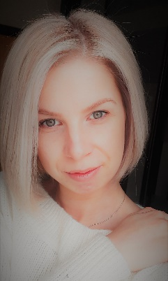
 | contact details
 |  | Ankabotanka8@gmail.com
 |  | Skype: pavlenkoann_1
 |  | www.linkdin.com/in/anyadotsenko
Zaporizhzhia, Ukraine
 |  | education and trainings

classic private university
BA in Import/Export Management

2012

training authority hacker
Shortgun Skyscraper Blueprint

2019
Introduction to Game localization, Udemy, 2020

