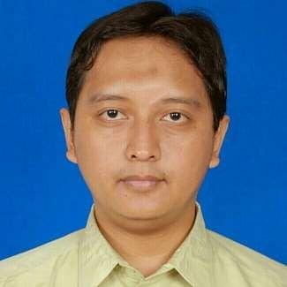
Resume of

Muhammad Rizal
Certified English into Indonesian Legal Translator and Subtitler

English into Indonesian certified legal translator by the Association of Indonesian Translators (HPI)

Phone (mobile): +628119901779 E-mail: rizal_oprex@yahoo.com

Websites: http://sihapei.hpi.or.id/find/term/Muhammad%20Rizal https://www.upwork.com/users/~011aa8eba5871f30bf http://www.proz.com/translator/1740905 http://www.translatorscafe.com/cafe/member203978.htm

BASIC INFORMATION AND COMPETENCIES:

- Native Indonesian of Sundanese ethnic group
- Bachelor Degree in English Literature specializing in Translation & Interpreting
- Familiar with CAT (Computer Aided Translation) software
- Able to speak and write English fluently, and Indonesian & Sundanese natively
- Experienced freelance translator & interpreter since 2003
- Experienced in subtitling since 2016

LANGUAGE PAIRS FOR TRANSLATION, INTERPRETING, AND SUBTITLING

- English to Indonesian
- Indonesian to English

- English to Sundanese
- Sundanese to English

FORMAL EDUCATION

2000 – 2005 : Bachelor Degree from Indonesia Education University majoring in English Literature
2000 – 2004 : Bachelor Degree from Bandung Law School majoring in Business Law 2005 – 2008 : Post Graduate Degree from Padjadjaran University majoring in Notary
Law

PROFESSIONAL EXPERIENCE

2010 – 2021 Legal Assistant Manager in PT Suzuki Indomobil Motor 2008 – 2010 Legal Staff in PT Humpuss in Jakarta
2005 – 2010 Part-time lecturer in Bina Sarana Informatika Academy

2014 Certified by Association of Indonesian Translators for English into Indonesian Legal Translation

FREELANCER SINCE 2003 FOR:

Translating, Proofreading/Editing, Terminology, Website & Software Localization

TRANSLATION OUTPUT

The average translation outputs are set as follows:
- English to Indonesian and English to Sundanese:
1500 source words (+/- 5 pages of 300 source words per page) per day
- Indonesian to English and Sundanese to English:
1000 source words (+/- 3 pages of 300 source words per page) per day

SPECIALIZATION FIELDS

Law (General, Contracts)

Experienced in using Aegisub (subtitling software) since 2016

ALSO CAPABLE FOR TRANSLATING

IT
Computer
Software & Website Localization Telecommunication
Journalism
Human Resource & Management Electronics
Technical Printer Game Tourism
Editing/Post Editing Machine Translation

Memberships

www.hpi.or.id www.proz.com www.upwork.com www.translatorscafe.com

