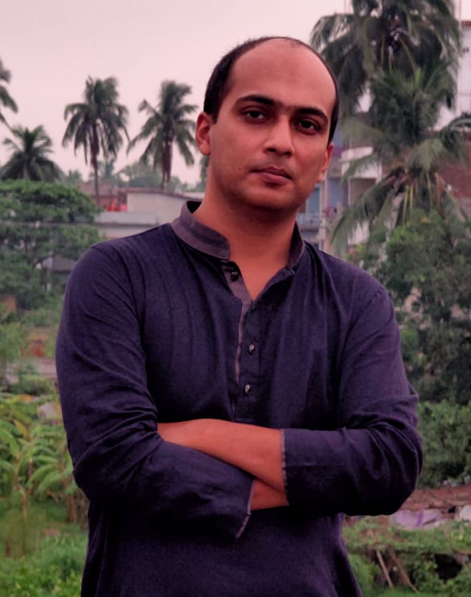
MOMTAZUL MOHIUDDIN
M.A. (English Literature)
- Lingual and Audio Services Provider
(Include Translation, Proofreading, Subtitle Creation with time coding, Transcription, Audio, Voice Over, Content Services.)
- Government Registered Freelance Linguist & Translator
Languages : Bangla / Bengali (Both the variants), English, Arabic, Hindi, and Assamese.

Software
CAT Tools: SDL Trados 2019, Cafe Tran Espresso, Memsource
Subtitle : Aegisub32, Subtitle Edit.
Audio : Adobe Audition, Logic, Pro Tools, Da Vinci Resolve.
Others : MS Office, Google Docs, Adobe Premier.

Professional Profiles:
https://www.linkedin.com/in/momtazul-mohiuddin-9b534380/
http://www.proz.com/translator/2033693
http://www.translationdirectory.com/translators/account/

-Professional translator with a skilled and experienced team (www.zemanticz.com), working locally and internationally for more than 10 years.

-Team: Zemanticz Lingual & Audio Services (www.zemanticz.com)

-Mother tongue: Bangla / Bengali and an expert of Indian and Bangladeshi variants.

-Second Language: Hindi.
-Third Language: English

-Netflix certified translator and working for Netflix, Amazon and SDL Plc., BBC as a Subtitle Artist, Subtitle and Audio QC and QC Verifier for more than two years.

-Legal, Medical, Media, Website, Apps, Software, Technical, Literal Translation Specialist.

-Experiences in Literary, Legal, Subtitle, Games, Technical (Vehicle), Technical, Medical and Health, Mechanical Engineering, and Website Translation specialist.

-www.proz.com plus member for around 3 years, and a general member for 6 years. Very good connection with native English, Arabic and all the Indian languages.

-Subtitle and Voice team with TV and Radio experiences.

-Associated with Studio Nocturne and Studio Musicare
Employment History

Company | Position | Duration
1. Zemanticz Lingual Services  www.zemanticz.com  Rajshahi, Bangladesh | Editor in Chief | Jan 2019 to Present
2. Shobdowala  www.shobdowala.com  Rajshahi, Bangladesh | Founder, Chief | 2013 to 2018
3. Lilt Inc.  San Francisco, USA | Freelance Translator & Reviewer | 2020 to Present
3. SDL plc.  Thailand | Subtitle Artist | 2018 to Present
4. Voice and Script International Ltd.  Aradco House, 128-134 Cleveland Street, London | Netflix QC Verifier | 2017 to Present
5. BBC Media Action  Bangladesh | Freelance Translator | Nov 2016- Jan 2016
6. VISTA Digital Media  www.vistaindia.com | Subtitle QC | March 2016- Jul 2016
7. RWS Moravia | Translator and Transcriptionist | Jan 2019 to Present
8. Cosmic Global Limited | Voice Over Team Coordinator (Vendor) | 2018 to Present
9. Shakti Enterprise,India | Translator and Proofreader | 2017 to Present
10. Eccellente Transcription and Translation Services | Translator and Transcription Team manager | March 2018 to Present
11. Somya Translators Pvt. Ltd. India | Translator and Proofreader | Jan 2016 to Present
12. Go Transparent  www.goransparent.com | Translator and Proofreader | Jan 2016 to Present
13. Global Translated Network Inc. | Translator and Proofreader | Jan 2016 to Present
14. RDS Translations UK  www.rdstranslations.com | Translator and Proofreader | 2015 to 2016
15. Easy Brand Check  www.easybrandcheck.com | Linguist | 2016 to Present
16. Ansh Translations | Translator | 2017 to Present
17. Amena Medical Assistant Training School, Talaimari, Rajshahi- 6100 | Assistant Professor | 2013 to 2018
18. Northern University of Bangladesh | Teaching Assistant | May 2010 to Aug 2010

Language | Bangla /  Bengali | English | Hindi | Arabic | Turkish
Translation Rate per Word | 0.06 | 0.06 | 0.05 | 0.05 | 0.06
Translation Rate Per Hour | 25.00 | 25.00 | 20.00 | 20.00 | 25.00
Subtitle Rate per Minute | 8.00 (with time code) | 8.00 (with time code) | 7.00 (with time code) | 7.00 (with time code) | 8.00 (with time code)
Subtitle Rate per  Hour | 50.00 (with time code) | 50.00 (with time code) | 45.00 (with time code) | 45.00 (with time code) | 50.00 (with time code)
Voice Over Rate per  Minute | 8.00 (with translation10.00) | 8.00 (with translation10.00) | 7.00 (with translation10.00) | 7.00 (with translation10.00) | 8.00 (with translation10.00)
Voice Over Rate per  Hour | 50.00 (with translation 60.00) | 50.00 (with translation 60.00) | 40.00 (with translation 60.00) | 40.00 (with translation 60.00) | 50.00 (with translation 60.00)
Transcription Rate per  minute | 5.00 | 5.00 | 5.00 | 5.00 | 5.00
Transcription Rate per audio  hour | 300.00 | 300.00 | 300.00 | 300.00 | 300.00

Rates in USD (negotiable):

Notable Accomplished Projects:
- Transcription and Review Support for Google that included heading a transcription team of 20 resources and provided 3200000 transcribed data with a final review and QC within 11 months with Eccellente and Transgalaxia.
- Language Lead for Lilt in Snap project.
- Working for Amazon as a linguistic services provider.
- Translation project of GSK Health Manual.
- Medical Translation from English to Bangla for Somya Translators Pvt. Ltd.
- More than 3000 minutes of Transcription within a month.
- Lead reviewer for Lilt Inc. in a translation and review project of Snap Corporation that included around 114000 words in Bangladeshi and Indian Bangla.
- Translation of Uber website and apps with Eccellente Pvt. Ltd.
- Subtitle, Subtitle for Deaf and Hard of Hearing, Closed Caption QC, QA, QC Verifier for NETFLIX for more than two years.
- Subtitle Support for Amazon Prime with SDL Plc.
- Voice Over support for Cosmic Global Limited.
- Subtitle Proof and QC Service for Vista India Limited.
- Legal projects with RDS Translations that included court papers, interviews with suspects and others.
- Technical and Mechanical Engineering experiences with Somya Translators Ltd..
- Project named "Amrai Pari" for BBC Media Action, Bangladesh.
- Translation of Privacy Policies of Samsung, Nokia, Apple and Microsoft.
- Translation of Training Manuals for UPS; translation and presentation.
- Translation of GSK Health Manual with Somya Translations.

Education
Exam Title | Major | Institute | Result | Passing Year | Duration | Achievement
M.A. | English | University of Rajshahi, Bangladesh | Second Class | 2009 | 1Year | 9th
B.A. | English | University of Rajshahi, Bangladesh | Second Class | 2008 | 4years | -
HSC | Science | Barendra College,Rajshahi | CGPA:3.5 | 2004 | 2years | -
SSC | Science | Rajshahi Govt.Madrasha,Rajshahi | First Division | 2000 | - | -

Personal Details:

Father’s Name: Md. Nazrul Islam
Mother’s Name: Most. Manjura Begum
Gender: Male
Date of Birth: 27th December, 1984
Nationality: Bangladeshi
Marital Status: Married
Spouse’s Name: Tabassum Islam
NID No.: 8198503110511

Address and Contacts:

F-332 AH Tower
(Opposite to Chamber of Commerce,Rajshahi)
Alokar Mor, Shashthitola,
Rajshahi-6100
Cell: +8801716760561 (WhatsApp, Google Meet, Telegram)
Web: www.zemanticz.com
Skype: momtazul.mohiuddin
E-mails:
m.mohiuddin3127@gmail.com
m.mohiuddin@zemanticz.com

Profiles:
https://www.linkedin.com/in/momtazul-mohiuddin-9b534380/

http://www.proz.com/translator/2033693

http://www.translationdirectory.com/translators/account/

