Maisel Rocha
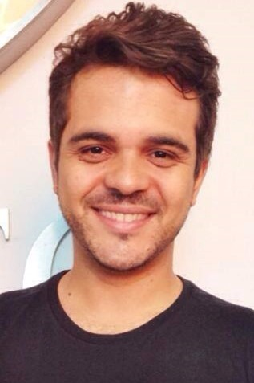

AREAS OF EXPERTISE
Proofreading
Interpreting
Multi lingual
European languages

PERSONAL SKILLS
Well organized
Detail-orientated
Proficient technical, formal and colloquial communication skills

PERSONAL DETAILS
Maisel Rocha
Nationality: Brazilian
DoB: 27/03/1980
rochatranslations@gmail.com
Cell: +55 31 8728 1646
Skype: maiselmarcia

Translator

PERSONAL SUMMARY
Reliable and talented translator, editor and proofreader with a proven ability to provide oral and written interpretation services, from English, Spanish and French to Brazilian Portuguese, with 15 years of experience in translation in South American, European and African countries.
KEY SKILLS AND COMPTETENCIES
- Highly skilled, with vast experience in written and oral translation from English, Spanish and French to Brazilian Portuguese.
- Expertise: international news and actualities, anthropological, theological, humanitarian, linguistic and medical texts and articles.
- Fluent in English, French, Spanish and Brazilian Portuguese.
- Able to prioritize work and to fulfill deadline commitments.
- Fully committed to delivering top-quality translation services.
WORK EXPERIENCE
- i2 Ministries Brazil, Translator (2005-Present)
Duties: translation, proofreading and edition of texts for overdubbing a curriculum of over 400 hours of video training (English-Portuguese). Overdub direction of over 40 hours of video of final overdubbed material (English-Portuguese). Translation, proofreading and edition of books, texts and articles on Theology, Tourism and International News (English-Portuguese). International speaker (English and Spanish) and interpreter (English-Portuguese, Portuguese-English, English-Spanish, French-Portuguese, Portuguese-French) in over 30 conferences in different countries.
- World Horizons, Humanitarian Worker (2000-2004)
Duties: humanitarian work, social development projects, language and culture learning and translation in South American, European and African countries.
- Freelance Translator (1999-Present)
Duties: written and oral translation services from English, Spanish and French to Portuguese.
- Freelance English and French Teacher.
- Author of 2 published books in Portuguese on vocational and humanitarian work issues.

ACADEMIC ACHIEVEMENTS
- MBA in People Management (Jan, 2015 – present)
Unicesumar, Maringá – Brazil
- Theology Degree (2008 – 2010)
Centro Universitário Izabella Hendrix, Belo Horizonte – Brazil
- Professional License in Nursing Technician (2004 – 2006)
Brazilian Red Cross School of Nursing, Belo Horizonte – Brazil
- French course and internship (November 2000-October 2001)
La Porte Ouverte, Chalon-Sûr-Saone, France; Horizons Mondiaux, Marrakech, Morocco
- English internship (Sep-Nov 2001)
Llanelli - Wales
- Spanish course and internship (Sep 2000 – Mar 2001)
Centro para las Naciones, Colonel Bogado – Paraguay
- Bachelor in Cross-Cultural Studies (1999-2004)
Missão Horizontes, Monte Verde – Brazil
- English course (1997-1998)
Spell School of Languages, São Paulo - Brazil
- Professional License in Electronics Technician (1995-1998)
Escola Técnica Estadual Professor Aprígio Gonzaga, São Paulo – Brazil

REFERENCES
Available on request.

